Wi-Fi Media Module is built into LCD Monitors
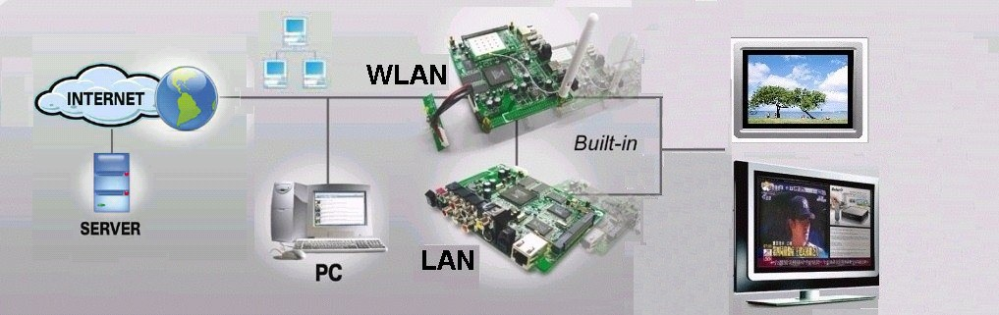

Features:

* Networking Advertisements on Demand.

* Integrated HDD or CF (optional).

* High Resolution Output (1080i).

* Automatic Synchronization With Server Time.

* Scheduled Download Content From Internet.

* Scheduled Playback Content at Local or Internet & Scheduled Play, Auto Start Play.

* Download List Supported.

* Wi-Fi Supports 802.11 b/g.

* USB Host 2.0 Storage Class Supported.

* Network Samba Protocol supported.
* Build WiFi Module in LCD Monitors (10.4”, 12.1”. 15”, 17”, 19”, 20”, 23”, 26”, 32”,
* 37”, 42”, 47”, 55” etc

Hardware Specifications
Video Output | Composite Video, S-Video, VGA Component Video, SCART
Video Format, | PAL 576i/576p, NTSC 480i/480p, HDTV 720p/1080i  (MPEG 1/2/4, MP3, WMV9, ISO)
Audio Output | Stereo, SPDIF Digital Audio Output on Optical.
WLAN | Mini PCI Card Slot for IEEE 802.11/b/g
Networking | Ethernet 10/100-BaseT, Supports Samba Client, DHCPC, NTP, FTP Client, Http file get.
Remote Control | 47 Keys

