VFD Customer Display
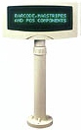

VFD Customer Display
Superior Image & Display Quality
Available for Pass-Through Connections
Optional Back LCD Display, Low-cost Double-Sides Display
Optional Pole/Base for Various Application
Features:
Vacuum Fluorescent Display with display 20 columns x 2 lines.
Blue-green fluorescent color is easy for the eyes.
The display panel is adjustable for the best viewing angle.
Adjustable height from 380mm to 550mm.
The interface is RS-232C, with baud rates from 300 up to 9600 bps.
Pass through function to reduce cable connections.
Optional back VFD display.
The user-defined and international character sets are built-in.

Specifications
Front VFD Display (2 x 20)
Customer display | Vacuum Fluorescent Display
Display pattern | 5 x 7 dot matrix
Brightness | 700 cd/m²
Character type | 95 Alphanumeric & 32 international
Character size | 6.4mm (W) x 9.2mm (H)
Back VFD display | Optional
Environment
Operating temperature | 0ºC to +40ºC
Storage temperature | -10ºC to +50ºC
Relative humidity | 0% to 90% RH
Driver Interface
Driver interface | RS-232
Driver command | ESC commands, AEDEX, UTC, EPSON, DSP-800
Overall Dimensions
Dimension (panel) | 110mm H x 220mm L x 45mm D
Dimension (support) | Telescopic pole from 270 to 440 mm
Dimension (base) | 12mm Height with 80mm OD
Viewing angle | Max. 45º
Horizontal rotation | Max. 360º
Weight | About 0.8 kg
Electricity
Power source | DC +9V~10V (Optional +5V, +24V)
Power consumption | 15 watts maximum 3 watts average
Connector | 8 pins phone jack, D-SUB 9, and 25 pins (female) connector

LCD Customer Display
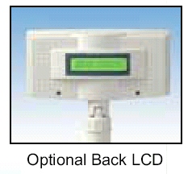 | LCD Customer Display  Display up to 40 Characters, 2 Lines x 20 Characters  Large font, Easy to Read  Most Competitive Pricing  Optional Back LCD Display, Low-cost Double-Sides Display  Features:  Display up to 40 characters, 2 lines x 20 characters.  Character Format: 5 x 7 dot matrix plus cursor per line  Character Generator ROM for 192 character types.  LED or CCFL backlight for providing high display quality  Provides powerful controller instructions.  Adjustable height from 380mm to 550mm.  International character type: English/JAPAN font, English/European font (Option), and English/Russian Font (Option).  STN yellow green or blue type LCD.
  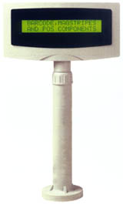
  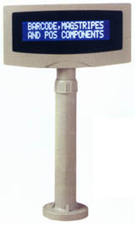
  Models | Description
  DSP-420 | Large font (6.00mmW x 9.66mmH),RS-232 interface
  DSP-422 | DSP-420 with Back LCD
  DSP-430 | Extra-large font (6.00mmW x 13.95mmH), RS-232 I/F & CCFL backlignt

Model | DSP-420 | DSP-430
Number of Characters | 20 characters x 2 lines | 20 characters x 2 lines
Viewing Area | 149.0 mm W x 23.0 mm H | 149.0 mm W x 33.0 mm H
Active Area | 142.8 mm W x 20.6 mm H | 142.8 mm W x 29.4 mm H
Character Size | 6.00 mm W x 9.66 mm H | 6.00 mm W x 13.95 mm H
Character Format | 5 x 7 Dots + Cursor | 5 x 7 Dots + Cursor
LCD Type | STN, Yellow Green | STN, Blue
Backlight Type | LED | CCFL
Interface | I/O Card, RS-232, Parallel | I/O Card, RS-232, Parallel
DC Power Source | +9V for RS-232 interface
Operating Temperature | 0ºC~60ºC
Storage Temperature | -10ºC~76ºC
Humidity | 10%~90% relative
Dimensions:  Display unit  Support Pole  Base | 110 mm H x 220 mm L x 45 mm D  Telescopic pole from 270 to 440mm  12mm Height with 80mm diameter
Tilt Angle | 45 Degree
Horizontal Angle | 360 Degree
Weight | Approx. 700 grams
Optional Back LCD Display
Customer display | Liquid Crystal Display
LCD Model | STN Negative, Blue
Display Pattern | 5 x 7 Dots + Cursor
Number of characters | 20 characters x 2 lines
Character Size | 3.2mm W x 5.5mm H
Backlight type | LED, Amber
Viewing Area | 85.0mm W x 18.6mm H

