Newest Fashion & Smart Sunglasses With MP3
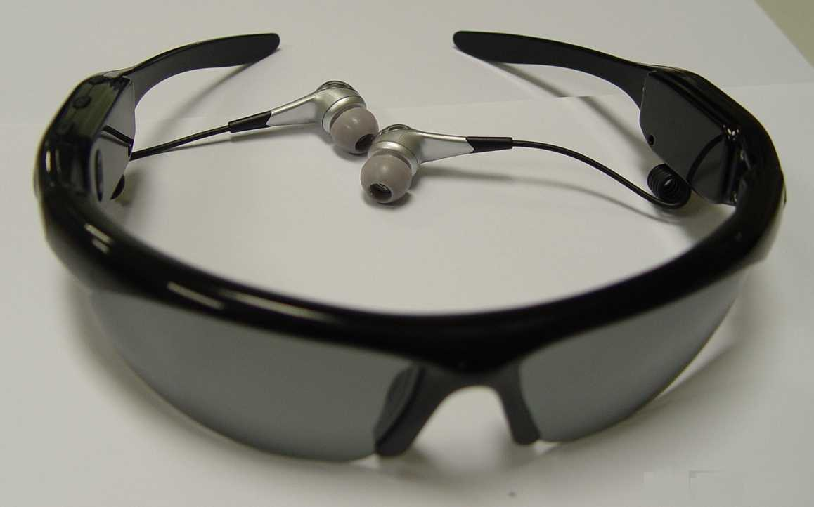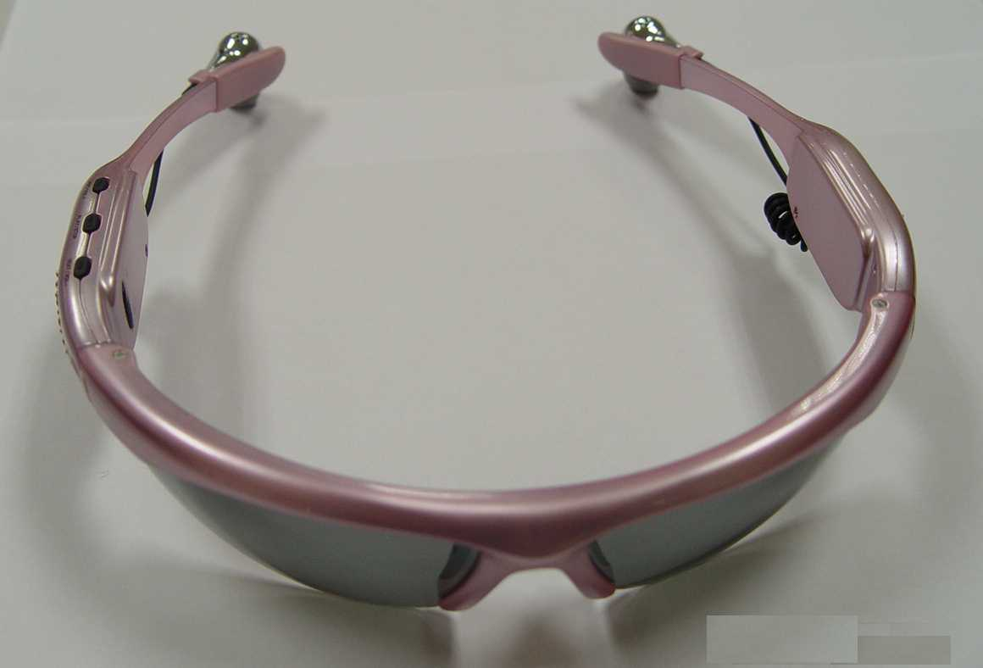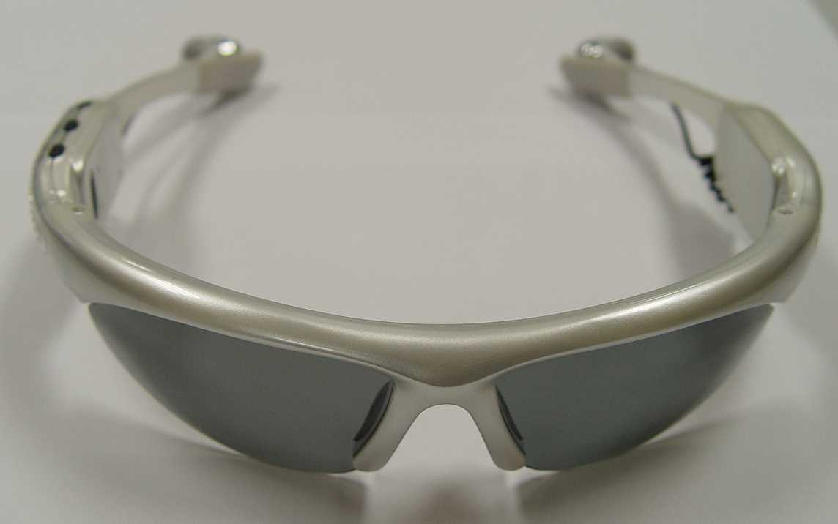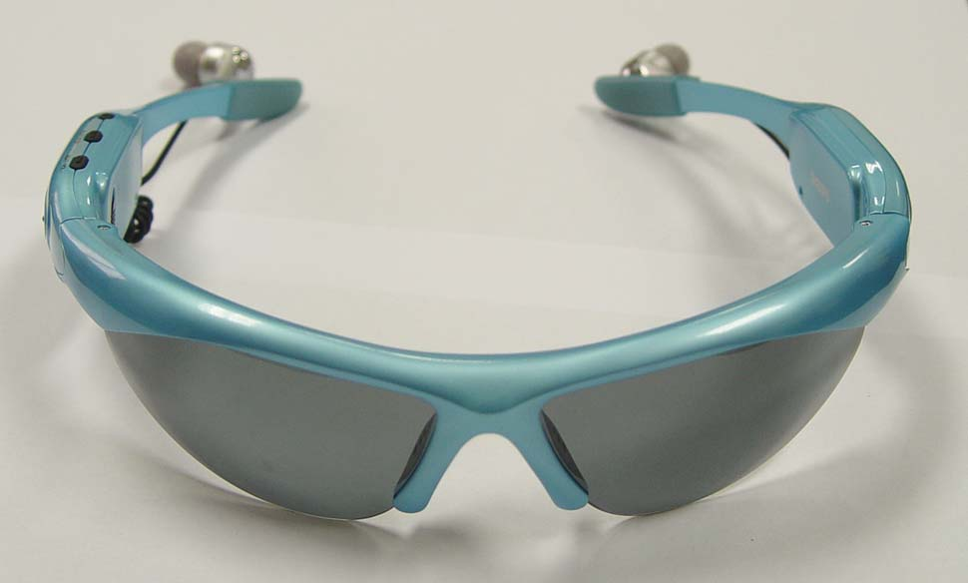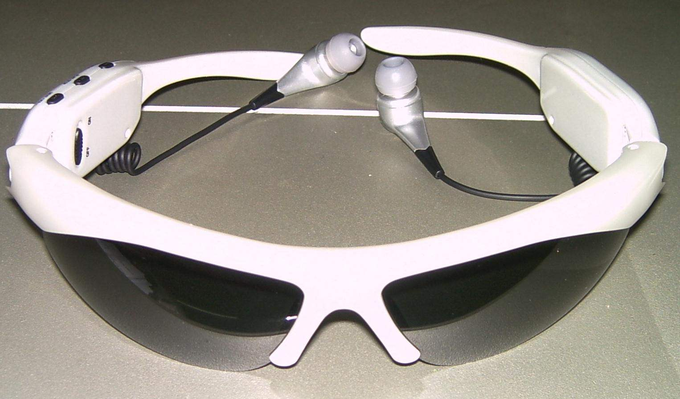
Black Color Pink Color Silver Color Pearl Green Color White Color
Function introduction
* Plug and Play
Plug and play under Win2000/XP. The MP3 device can be a common Removable drive.
* Encryption and partition The MP3 device can be partition into two drives. either one can be encrypted, the encryption and partition software is provided in the CD Rom.
* Polarized Sunglass Lenses

Size | 165.0mm * 165.0mm * 38.5mm
Weight | Net weight: 46.9g (with rechargeable battery)
Indicator light | red indicator / blue indicator
PC Link | USB2.0 (read 1000K Byte , write 800K Byte)
Memory | Flash memory: 32M/ 64M/ 128M/ 256M/ 512M/ 1G/ 2G
Power | Rechargeable battery can operate up to 7 hours
MP3 、WMA、WMV、 ASF | earphone max. output | (L) 10mW+ (R) 10mW (160hm)
MP3 、WMA、WMV、 ASF | MP3 bit rate | 8K bps - 320K bps
MP3 、WMA、WMV、 ASF | WMA、WMV、 ASF bit rate | 5K bps - 384K bps
MP3 、WMA、WMV、 ASF | Frequency response | 20Hz - 20KHz
MP3 、WMA、WMV、 ASF | noise ratio | 85dB
Music mode | MP1、MP2、MP3、WMA、WMV、ASF、WAV
Temperature | - 5 ~ 40 Celsius
Support system | Windows98/ SE/ ME/ 2K/ XP、Mac OS 10、Linux2.4.2
Safety | CE & RoHS

