10.4” Splash Proof LCD TV Monitor
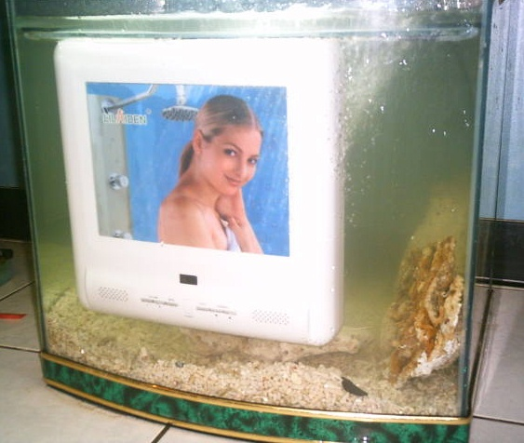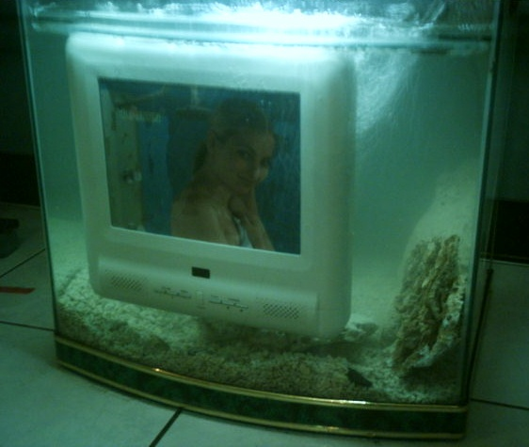
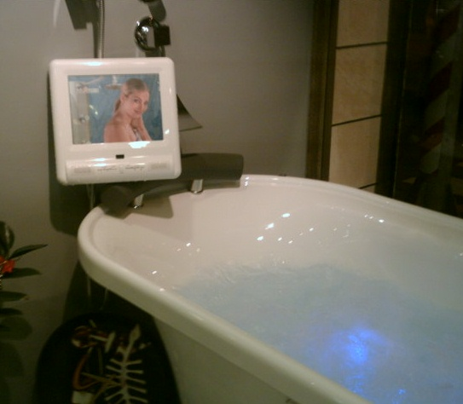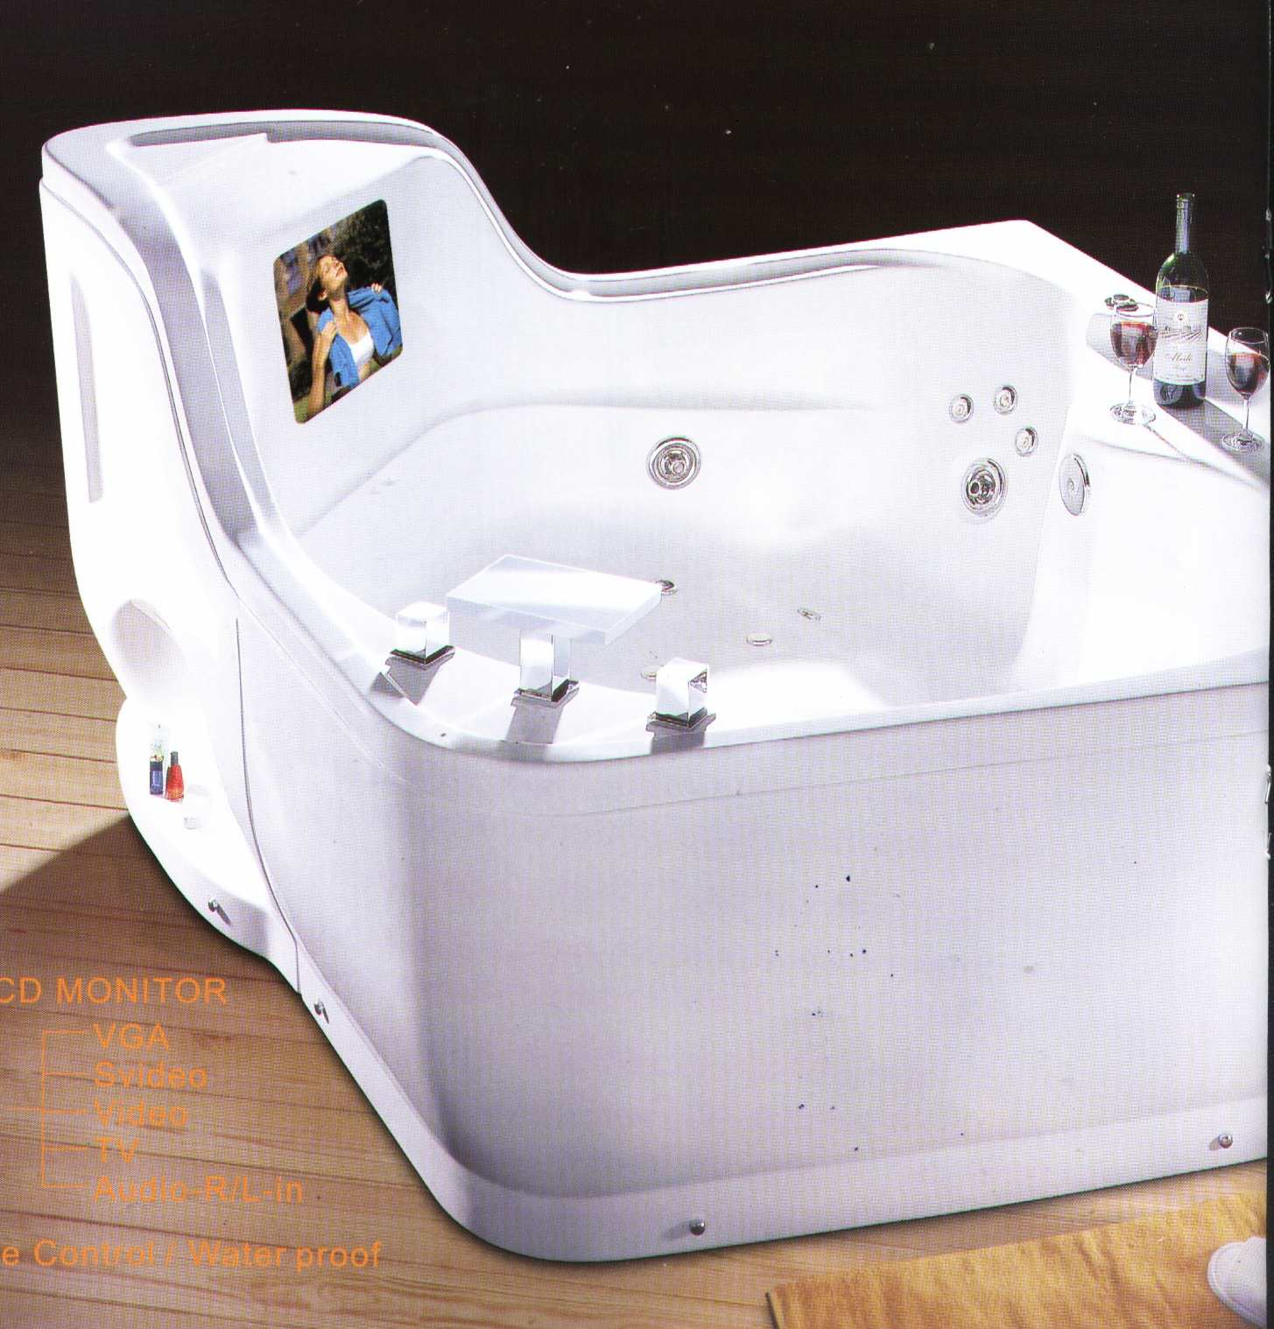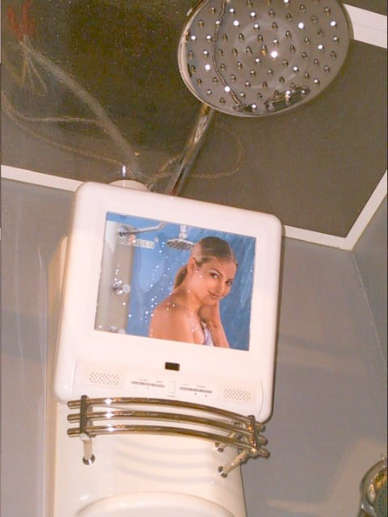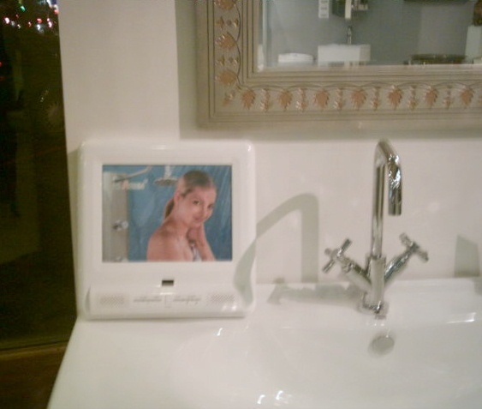

LCD Display | 10.4” TFT LCD Display
Resolution | 800 x 600/ 640 x 480
Response Time | Rising 25 ms, falling:35 ms
Contrast Ratio | 250 : 1(Typ)
Brightness | 200 cd/m²(Typ)
Viewing Angle | R/L: 50/50˚, U/D: 50/15˚
Video Input | Composite Video, (RCA) x 1(NTSC/PAL/SECAM)  Built in TV Tuner(NTSC,PAL or SECAM)  VGA Input (Optional)  DVB-T (Optional)
Audio Input | Stereo Sound Input (RCA)(F) ×2
Audio Output | 5W Speaker ×2
Power Consumption | 48W(MAX, +12Vdc/4A)
Power Input Range | DC +10V~35V
Control Function | OSD/Remote Control (Splash Proof)
Temperature | Operation: 0~50°C, Storage: -5 ~ +60°C
Dimension/Weight | 294 x 292 x 45mm (L x W x H)/2.2 kg
Certification | CE, FCC, UL, RoHS, IPX6, IP5X

