7” Splash Proof TV Monitor
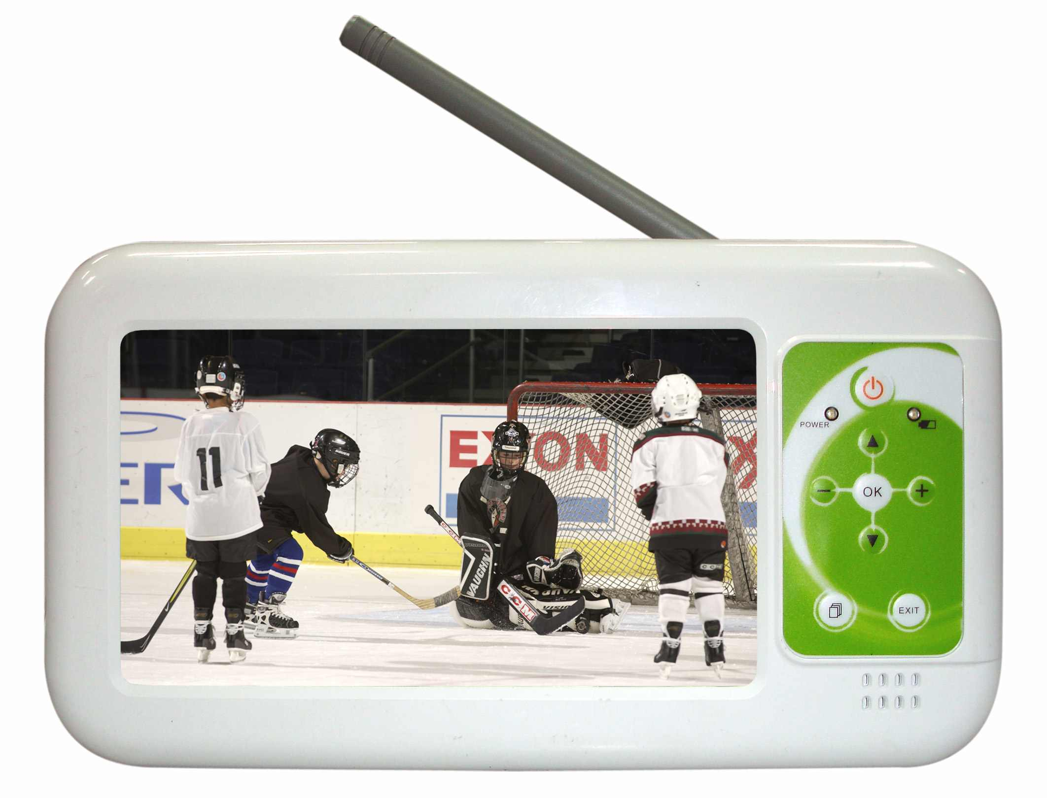
Features:
* Splash Proof (IPX4)
* Wide Screen
* Built-in DVB-T or Analog TV
* Built-in Rechargeable Battery
* Video Output
* Earphone Jack

Specification:
LCD Display | 7” TFT LCD Display
Resolution | 480 (H) x 234 (V)
Response Time | Rising: 12 ms, falling: 18 ms
Contrast Ratio | 300 : 1(Typ)
Brightness | 400 cd/m²(Typ)
Viewing Angle | R/L: 60/60˚, U/D: 40/60˚
Video Input | DVB-T or Analog TV
Video Output | Composite Video x 1
Power Input | DC 12V, Built-in Rechargeable Ni-MH Battery
Audio Output | Built-in 2W Speaker, Earphone Jack
Control Function | Display Key Control
Temperature | Operation: 0~60°C, Storage: 0~+70°C
Dimension/Weight | 240 x 132 x 68mm (L x H x D)/1.5 kg
Certification | CE, FCC, UL, RoHS, IPX6, IP5X.

