Secure Digital (SD) Interface Laser Barcode Scanner
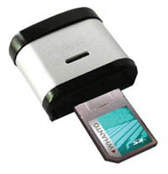
Interface | Secure Digital
Barcodes Supported | UPC-A, UPC-E, EAN-13,/JAN-13, EAN-8/JAN-8, CODE 39, CODE 128, CODABAR/NW7, Interleave 2/5, Industrial 2/5, Matrix 2/5, CODE 93, CODE 11, China Postage, MSI/PLESSEY.
Software Compatibility | Windows CE, Pocket PC 2002/2003,Palm OS 5.X or later with SDIO interface
Hardware Compatibility | HP iPAQ 19XX/3900/4XXX/22XX/5XXX, Mio 339
Sensor | Sensor Diode
Light Source | Laser Diode
Ambient Light | 100,000 lux Max. (Sunlight), 4500 lux Max. (Fluorescent lamp)
Width of Field | 25 inch
Depth of Field | 66 inch/40 mil code width
Resolution | 4 mil(0.1mm)
Voltage | DC +5V ±5%
Power Consumption | Power On 100mA
Reading Indicator | Beeper and LED
Scan Rate | 100 scans/sec
Operating Temp | 0 °C to 40 °C
Storage Temp | 20 °C to 60 °C
Relative Humidity | 20% to 85% (Non-Condensing)
Housing Material | ABS Plastic & Rubber
Weight | Approx. 40g

