The RF Bar Code Laser Gun, model RFL-8000, and base station use real-time bidirectional radio frequency transmission for point-to-point or networked communication between host computer and scanner. The ideal choice for scanning jobs in retail, light warehouse and manufacturing environments. With transmission ranges of of up to15 meters with internal antenna and 100 meters with external antenna the RFL-8000 is also ideal for scanning larger warehouse and hard to reach items.
The RFL-8000 base station can be connected to a host with keyboard wedge, RS-232, OCIA, RS422 or RS485 interfaced devices. One base station can communicate with up to eight scanners simultaneously. Additional biderictional transmission allows each scanner to one hundred percent confirm receipt of data at the host terminal.
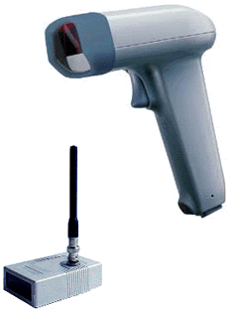
RFL-8000 GUN SPECS
- Light Source - visible (670mm)
- Scan Rate - 100 scans per second
- Resolution - 0.125mm (5mil) at PCS 0.9
- Reading Distance - 1 to 42cm (resolution dependent)
- Battery Capacity - 2000 scans or six hours
- Radio Range - 15m minimum
- Weight - 250g
- Frequency - 433.92MHz (Euro Std.)
- Power Output - max. 10mW (Euro Std.)
- Modulation - AM (00K)
- Antenna - Built-in
- Channels - up to 8 (virtual)
- Multi-user - up to 8 user simultaneously
- ID Address - configurable by menu barcode
RFL-8000 BASE SPECS
- Frequency - 433.92MHz (Euro Std.)
- Power Output - max. 10mW (Euro Std.)
- Modulation - AM (00K)
- Communication - Bidirectional (ack only)
- Antenna - External
- Power Supply - 9V DC 200mAh
- Channels - up to 8 (virtual)
- ID Address - configurable by menu barcode
- Output Interface - RS232 / Keyboard
