POS Receipt Printer (Direct Thermal)
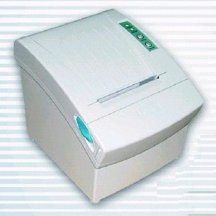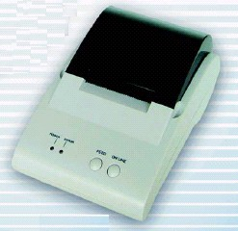

P080 P058

Features:
- User friendly, easy to install paper roll
- Halt on protect function for over heat
- Optional serial or parallel port
- Cash drawer connection port
- ESC/POS print commands set

Specification
Model Number | P058 | P080
Printing method | Direct thermal | Direct thermal
Max paper width | 57.5mm | 79.5mm
Character per line | 32 (Front A) | 48 (Front A)
print width | 48mm | 72mm
Print speed | Approx. 52mm/sec or 14 lines/sec | 220mm/sec (max.) or 58 lines/sec
Print density | 384 dots/line or 8 dots/mm | 576 dots/line or 8 dots/mm
Dot space | 0.125mm | 0.125mm
Print life | 50km | 100km
Halt on protection | 60℃ | 80℃
Serial port | Dsub 25 pin female connector, 9600 bps baud rate, none parity, 8 data bits and 1 stop bit, supports RTS/CTS & XON/XOFF protocol | Dsub 25 pin female connector, 19200 or 38400 bps baud rate, none parity, 8 data bits and 1 stop bit, supports RTS/CTS & XON/XOFF protocol
Parallel port | Dsub 25 pin male connector, 8 bits parallel, supports BUSY protocol | 36 pin Centronics connector, 8 bits parallel, supports BUSY protocol
Cash drawer port | DC 12V/1A, 6 wires RJ-11 socket | DC 12V/1A, 6 wires RJ-11 socket
Dimension | 185(L) x 114(W) x 90(W) mm | 190(L) x 145(W) x 147(W) mm
Weight | 740 g (w/o cable) | 1400 g (w/o cable)
Power source | 100/240 VAC, 50/60 Hz  8.8V DC/3.5A (Output) | 100/240 VAC, 50/60 Hz, 24V DC/3.0A
Operating | 0ºC~45ºC 20~80% RH | 0ºC~45ºC 10~90% RH
Storage | -10ºC~50ºC 10~90% RH | -10ºC~50ºC 10~90% RH
Print font: ASCII code  Graphic font | 12x24 dots, 1.25mm (W) x 3mm (H)  24x24 dots, 3mm (W) x 3mm(H) | 12 x 24 dots, 1.25mm (W) x 3mm(H)  24x24 dots, 3mm (W) x 3mm(H)
Paper adopted | Direct thermal printing paper | Direct thermal printing paper
Max. Paper roll | 50mm (Diameter) | 83mm (Diameter)
Paper thickness | 53-60 g/m2 | 53-60 g/m2
Auto Cutter | None | Life span: over 1,000,000 cuts

