60/80/96/128/137/152 Key POS Programmable Keyboard
Features:
* User- define keycap functions
* Able to download and edit data under DOS, Window 98/2000/ME and Windows NT4.0
* External Magnetic card reader combination (optional)

Specifications:
Interface | Standard PC AT K/B Wedge (PC DIN 5 or PS/2 connector)
Power | Voltage: 5 volts ± 5%
Dimension (LxWxH) | 60 key K/B: 215 x 245 x 37.8mm (w/MSR), 1.25kg  60 key K/B: 215 x 245 x 35mm (w/o MSR), 1kg  80 key K/B: 215 x 245 x 37.8mm, 1.25kg  96 key K/B: 300x 215 x 45mm (w/MSR), 1.7kg  96 key K/B: 270x 215 x 45mm (w/o MSR), 1.5kg  128 key K/B: 335 x 235 x 57mm, 1.9kg  137 key K/B: 450 x 220 x 50mm, 1.9kg  152 key K/B: 450 x 220 x 50mm, 2kg
Key Switch | Cherry Switch With Click/Tactile Type (MXIA-EINW)
Programming Feature | Each key can be programmed up to 15 key codes  Editable and Downloadable under Windows 98/2000/ME and Windows NT 4.0  Users-configurable single/double/quad keycap functions  Inter-character delay time: 0-255ms  Macros saved in the keyboard
Magnetic Card Reader | Track(s):comply ISO standard 1,2,3 combination

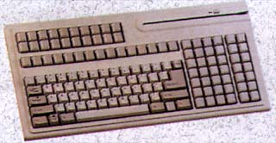 | 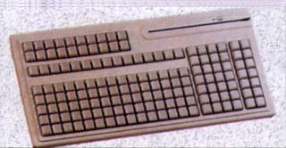
KB-137 | KB-152

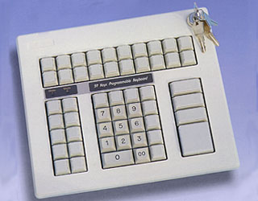 | 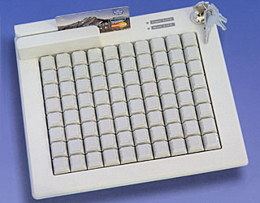 | 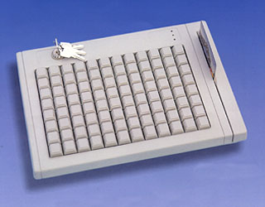 | 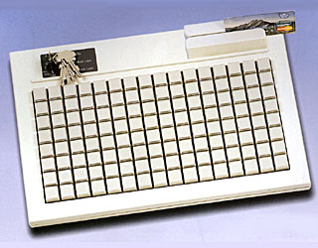
KB-60 | KB-80 | KB-96 | KB-128

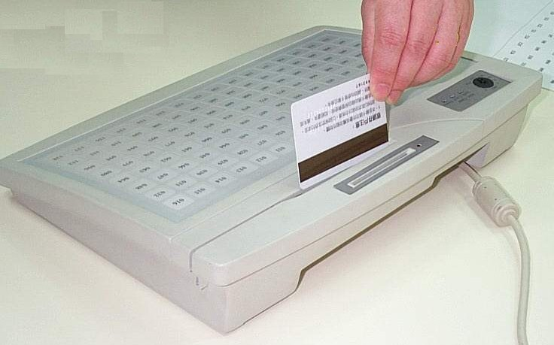

SMK-128 MEMBRANCE K/B
All keycaps are relegendable
IBM compatible keyboard with 128 freely programmable functions keys
Spill & Dust Proof
Can be programmed under DOS, WINODWS 95/98 or NT4.0/5.0
Friendly download utility to define key codes
With extension PS/2 connector
Optional IC card reader, Bar Code Reader &l Magnetic Stripe Card Reader
functions
Optional 8 positions Key Lock functions
Net Weight: 600g,
Dimension: 335x235x57 mm (LxWxH)

