15”/17” Panel PC Systems
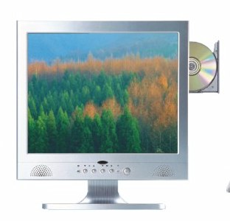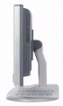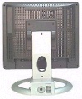

SPECIFICATIONS
LCD PANEL | 15" color TFT, 1024*768, 250 nits  17” color TFT, 1280*1024, 250 nits
CHIPSET | SiS M661FX & SiS 963
CPU | Intel Pentium 4 (Up to 3.6 GHz, 400/533/800 MHz FSB)  Intel Celeron (Up to 2.80 GHz, 400/533 MHz FSB)  Support Prescott / Hyper-Threading CPU
DISPLAY | Integrated In SiS M661FX (Share Memory 16~128MB)
MEMORY | 2 * 184 pin DIMM Sockets Support up to 2GB, PC3200/PC2700/2100 (DDR400/333/266) Non-ECC DDR SDRAM Memory
HDD | 3.5” 80GB (Up to 160GB)
OPTICAL DEVICE | Slim CD-ROM/DVD-ROM/Combo (CD/DVD-ROM) (Optional)
AUDIO | Built in 2 x Speakers, Realtek ALC655 6 Channel AC97 Rev 2.3 Codec
SPEAKER | Internal Speakers*2
Expansion Slots | 1 x Mini PCI Slot (Internal Slot)
ETHERNET | Realtek 8100C/8110S Lan Conntroller Supporting 10/100/1000 Base-T Ethernet (WAKE-ON-LAN) x 1 Port. (Optional: 2 Lan Port)
WIRELESS LAN | 32 bit Mini-PCI Card Interface (Optional), Support 64 and 128 bit WEP Encryption  802.11b: 11Mbps Up to 180 M (Outdoor), 35-60M (Indoor)  802.11g: 54Mbps Up to 50 M (Outdoor), 20M (Indoor)
IEEE 1394 | South Bridge, 1394 PHY FW801A With 1 x 1394 Port
USB PORT | Max. 6 x USB 2.0 Ports
I/O PORTS | 1 x PS/2 Keyboard & 1 x PS/2 Mouse  1 x RJ45  4 x USB 2.0/1.1  1 x IEEE 1394  1 x Parallel  1 x Serial  1 x VGA  1 x Composite Video  1 x Audio I/O  1x Power Connector
WATCH DOG | Can be set by 500ms, 1, 2, 4 Seconds Period. RESET or NMI was  Generated when CPU did not periodically trigger the timer.
TOUCHSCREEN | 4-Wire Resistive Type
POWER LOST RECOVERY | System will auto power on when power failure
POWER ADAPTER | Input: AC/100~240V (50/69Hz), 2.5A  Output: DC/20V, 7.5A, 150W
CERTIFICATION | FCC, CE, CCC.

