Omni Directional Barcode Laser Scanner
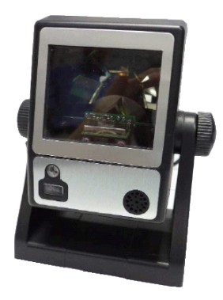T
Light source | 650nm visible laser diode
Depth of Scan Field | 0-210mm@ UPC/EAN 100%, PCS
Number of Scan Lines | 20
Scan Pattern | 5 directions of scan field
Scan Speed | 1200 scan per second
Minimum Bar Width | 5mil @ PCS 90%
Print Contrast | 30% @ UPC/EAN100%
Indicators (LED) | two-color LED (red and green)
Decode Capabilities | UPC/EAN/JAN, UPC Versions A&E, EAN-8, EAN-13, JAN-8, JAN-13,  Addendum 2 or 5, ISBN/ISSN, Japanese Bookland, Code 39 (with full  ASCII), Codabar (NW7), Code 128/EAN 128, Code93, Interleaved 2 of 5, MSI/Plessey, China Post Code, Code 32 (Italian Pharmacoe) Optional: Industrial 2 of 5, Standard 2 of 5, Discrete 2 of 5, Matrix 2 of 5, IATA Code, Code-11, RSS-14, RSS-Expanded, RSS-Limited
Beeper | Programmable tone and beep time
Interfaces | Keyboard, RS-232C, USB1.1, Wand
Dimension | 120.5 x 108.3 x 71.35 mm
Weight | 250g
Cable | Standard 2m straight
Input Voltage | 5VDC+10%
Power | 1.0Watts
Operating Current | 200mA@ 5.0V
Laser Class | CDRH Class IIa, IEC 60825-1: Class
EMC | CE&FCC DOC compliance
Operating Temperature | 0℃ to 40 ℃
Storage Temperature | -20℃ to 60 ℃
Humidity | 5%-95% RH (non-condensing)
Light Level | max. 2500LUX (fluorescent)
Shock Resistance | Designed to withstand 1m drops

