Mirror LCD TV Monitors

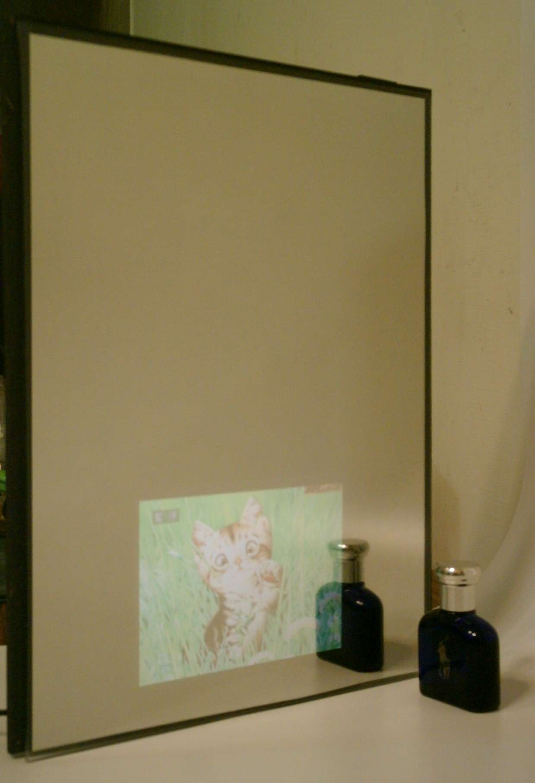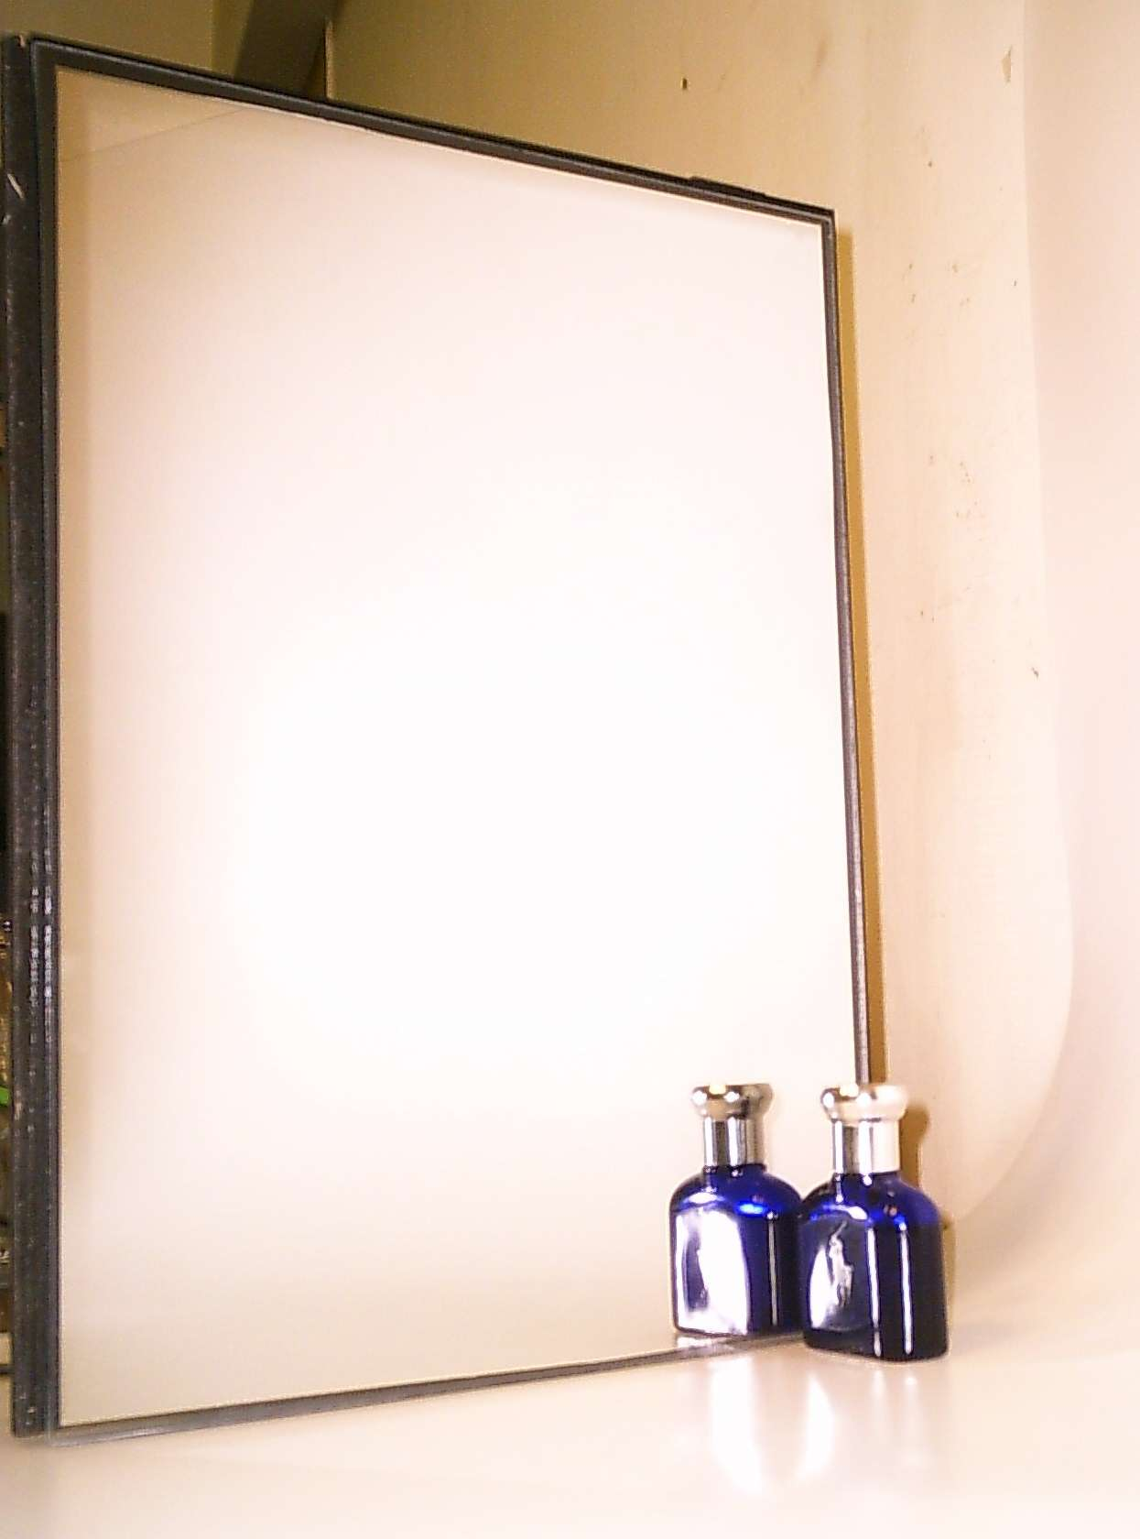

Honor Star " Mirror LCD TV Monitors" offer high quality video
pictures through a special mirror material which allows near total
transmission of the polarized light output of the LCD screen.

The " Mirror LCD TV Monitors" have wide range applications:
a). Advertising
b). As PC screen
c). TV sets
d). Regular mirror
e). Others.

It can be used in barbershop, bathroom, lobby, public locations...etc

If you have inquiries, please provide following response for our best
offers, we will also send more details to you again soon.

a). What inputs ? TV, VGA, AV ?
b). What sizes of LCD TV monitors ?
c). What is your TV system ? NTSC, PAL(B,G, K...etc),...etc
d). What dimension of mirror glass (max: 50 x 120cm) ?
e). Is the mirror glass on " Vertical " or " Horizontal " position ?
f). Where is the location of LCD TV monitor on the mirror glass ?
g). What q'ty ?

Looking forward to receiving your prompt and positive response

