Magnetic Card Reader 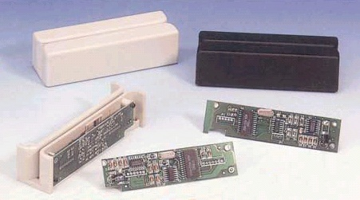

The MCR Series are undecoded TTL reader, designed with low power mask IC for TTL interface.

Using high quality magnetic head, the MCR reader not only provides superior reading performance, but also guarantee more than 300,000 passed.

The reader can be offered with or without cover, and the mask ICs / PCBs / Circuits / Modules can be upon OEM request.

Features:
* Module housing is available in 90 mm length and 100 mm length, suitable for
most applications
* Mask IC for single and dual channel F2F amplificating and decoding.
* Meet the specifications of ISO 7810 / 7811 / 7812 / 7813 and JIS X6301 / X6302
* Support reading the card with 210 BPI and 75 BPI recording density.
* Optional models with single, dual and triple track configurations.

Specifications

- Card Standard: ISO 7810 / 7811 / 7812 / 7813, X6301 / X6302 (JIS-I & II)
- Power Supply: +5VDC (+/-5%)
- Power Consumption: Less than 10mA
- Recording Method: F2F
- Output Level: TTL compatible
- Head Lifetime: Min. 300,000 passes
- Card Feeding Speed: 10~100 cm/sec for reading
- Operating Temperature: 0℃~ +55℃
- Humidity: 20~90% RH
- Dimension: 100mm (L) x 26mm (H) x 27mm (W)
90 mm (L) x 24mm (H) x 22mm (W)

