LCD (Touch) Monitors in Metal Chassis/Open Frame:

6.4”/8.4” (640 x 480/800 x 600)
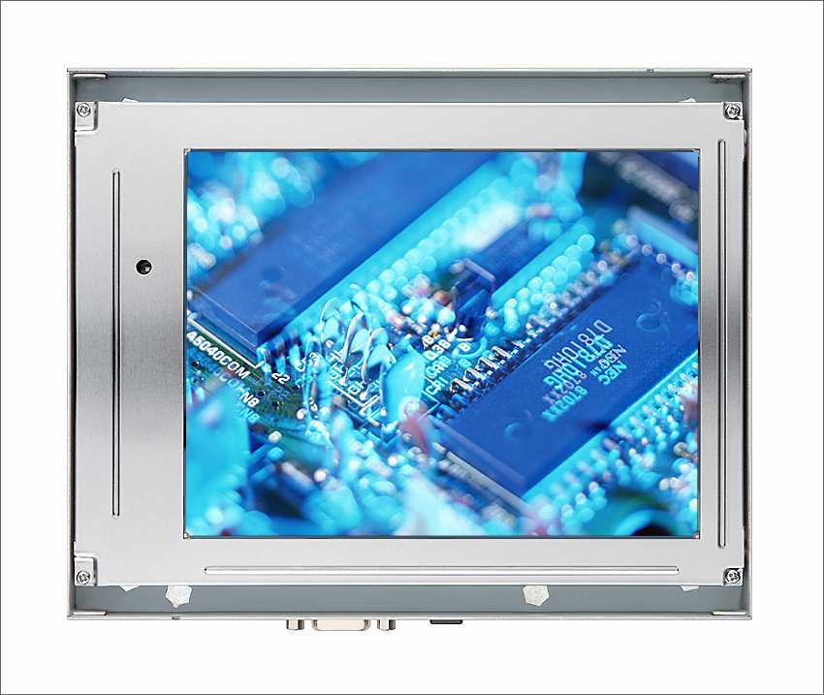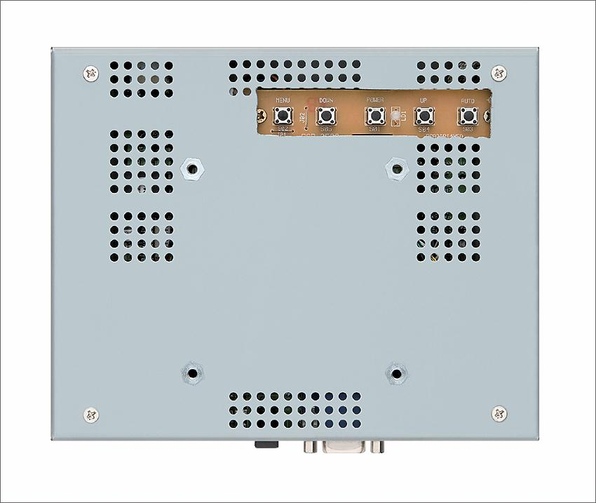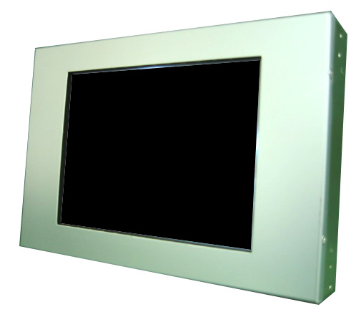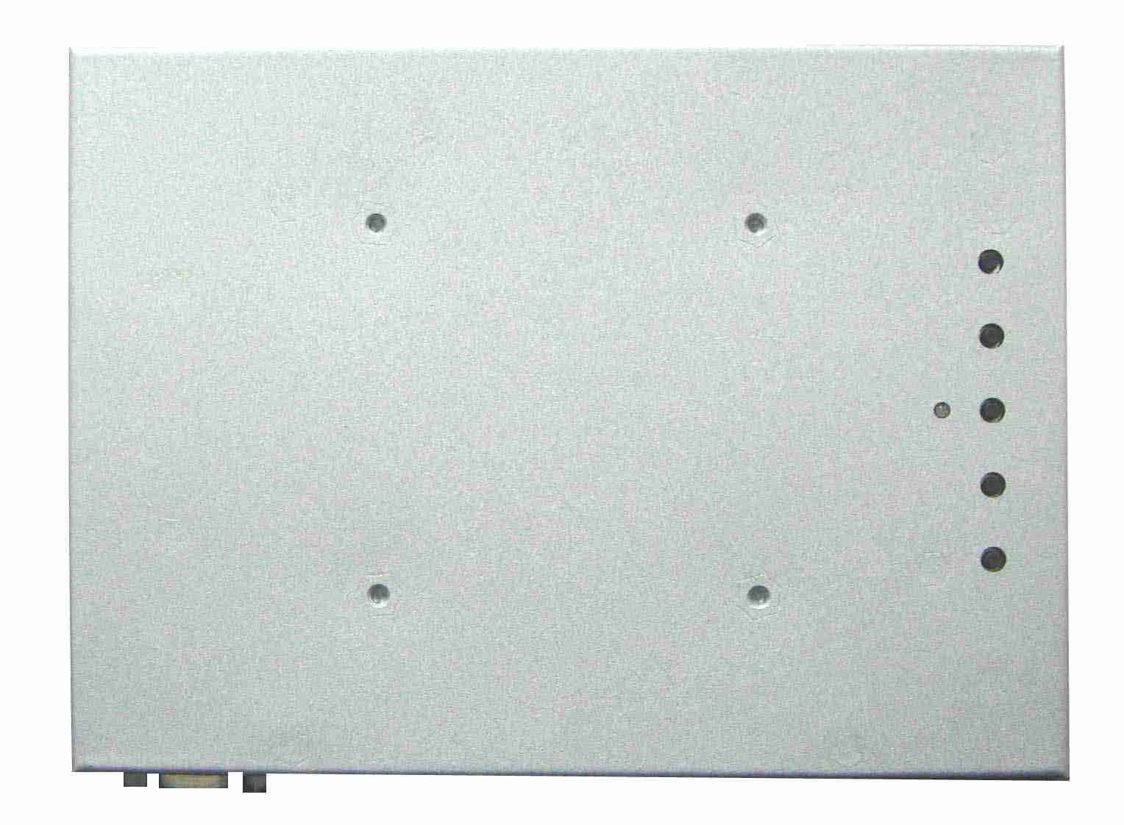
10.4”/12.1” (800 x 600/1024 x 768)
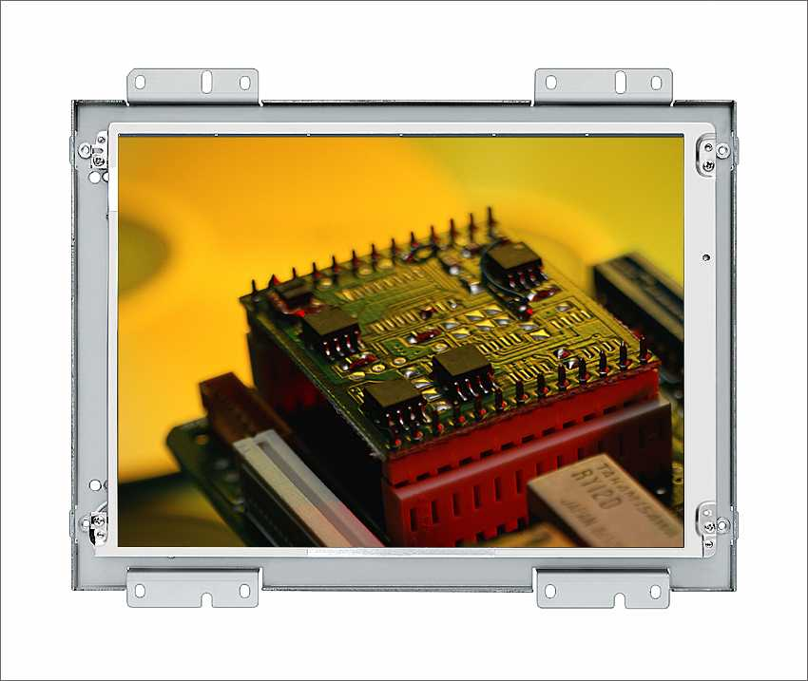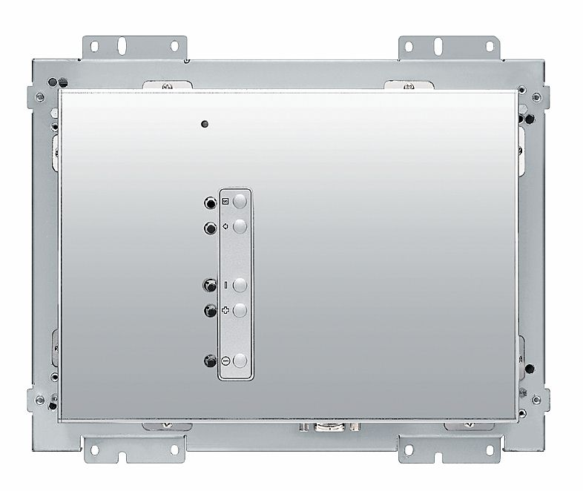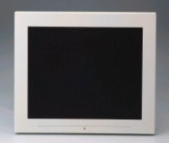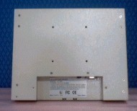
15” (1024 x 768)/17”/19” (1280 x 1024)
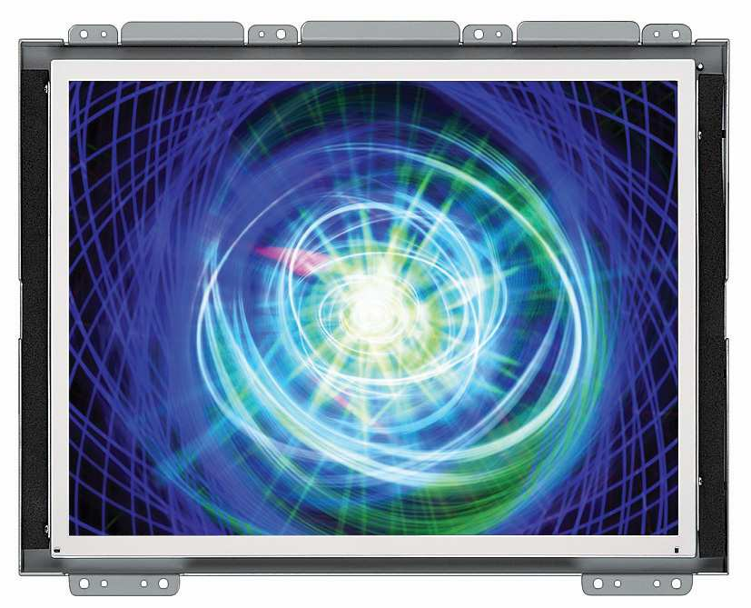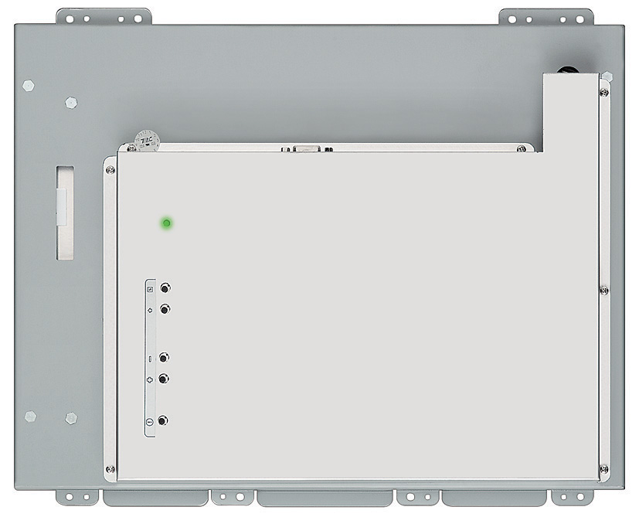

20” (800x600/1366x768/1600x1200)
23”, 26”, 32”, 37”, 42”, 47”, 55” (1280 x 768/1366 x 768/1920 x 1080)

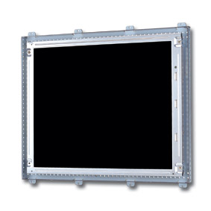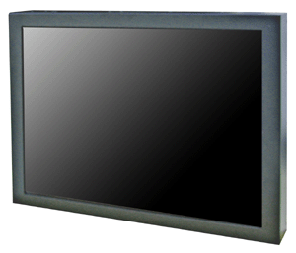
Open Frame Metal Chassis

We accept different specifications of LCD panels.

