LCD Monitors With Media Player (Desktop, Wall Mount):

a). 4”, 320x240/300 cd/m² b). 5”, 320x240/400 cd/m² c). 8”, 640x480/380 cd/m²

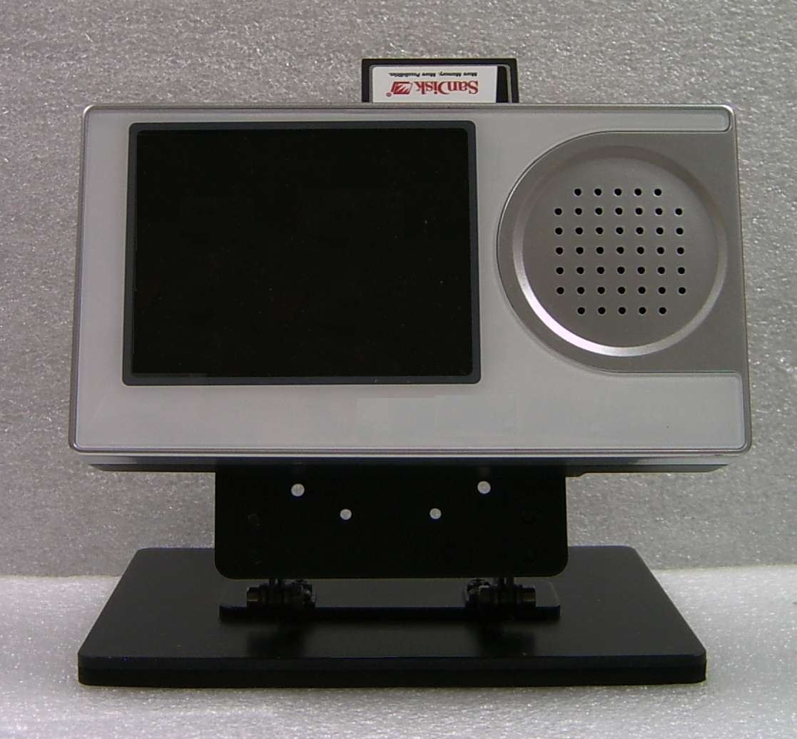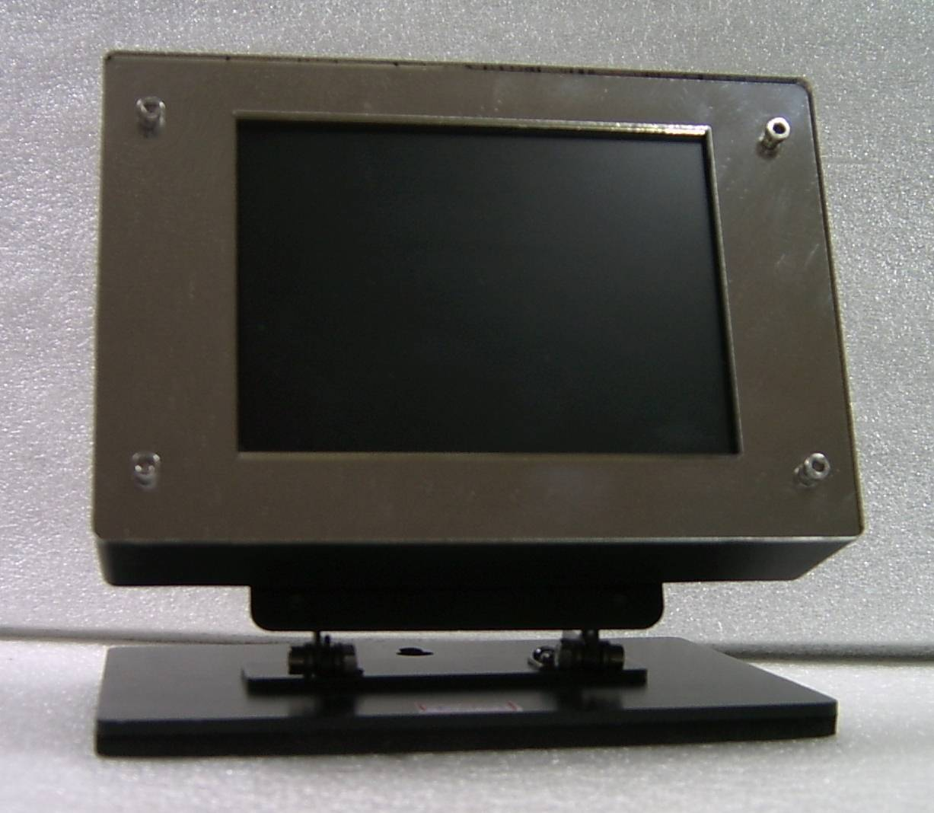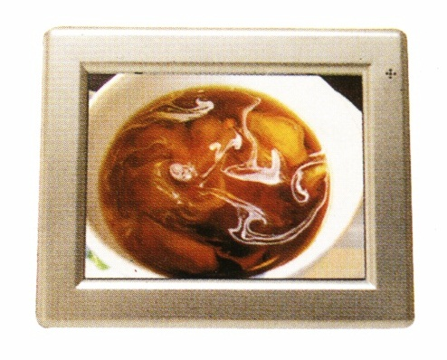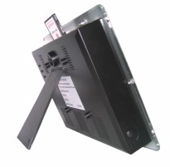

d). 10”, 800x600/380 cd/m² e). 10.4”, 640x480/380 cd/m² f). 15”, 1024x768/250 cd/m²
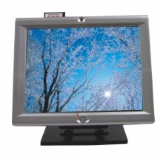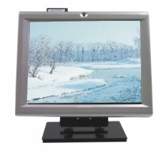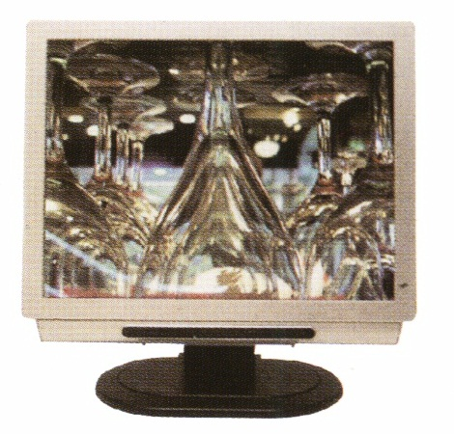

g). 17”/19”, 1280x1024/300 cd/m²
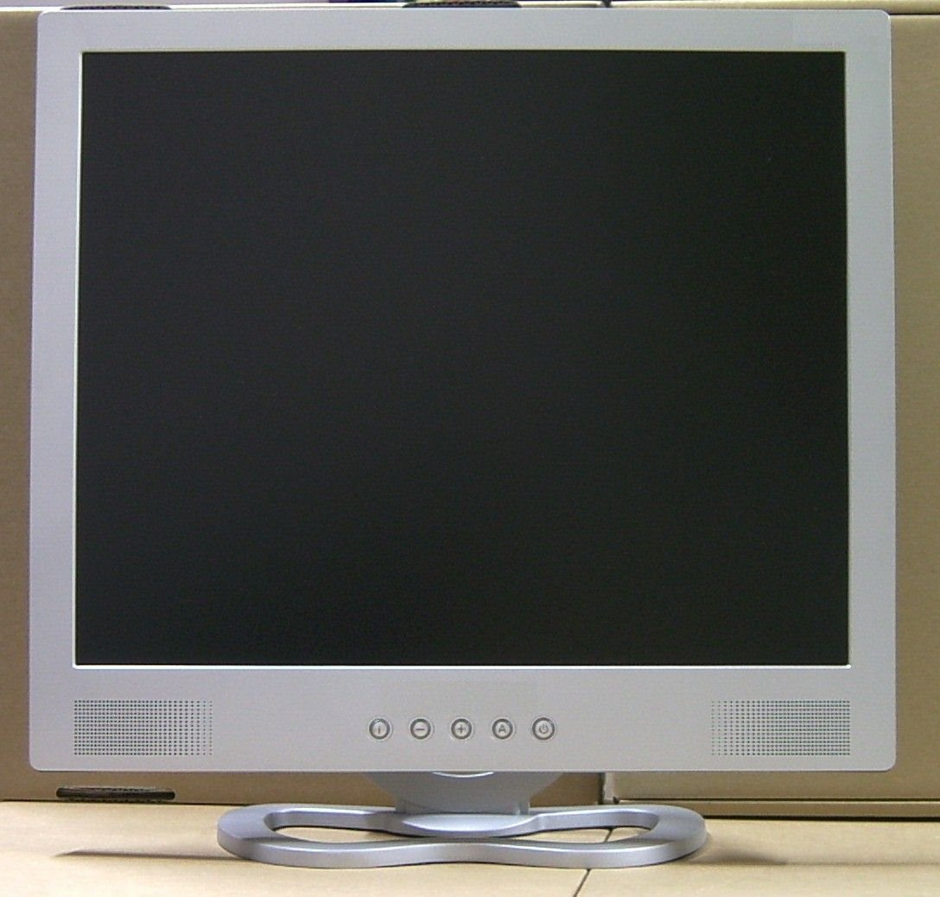

Specifications of Media Player
Memory Card Supported | CFI, CFII, SD, XD, MS, MMC, IBM Micro Drive, Smart Media, MS-Pro, MS-Duo, Mini SD, RSMMC
Video Format supported | MPEG I/II, MPEG-4 (ASF simple profile 320 x 240 video)
Audio Format supported | MP3, WMA, WAV, OGG (Mp3 min. 32 Kbps, Max. 256 Kbps)
Photo | JPEG, Motion JPEG (AVI), (JPG min. 16 x 16 pixels, max. 5120 x 3840 pixels), (Motion JPG max. 10 fps)
Connections | Composite Video, S-Video, VGA, Audio
Remote Control | 24 Keys
Automatic Slide Show | Yes
Power | AC100-240V, 50~60 Hz, Output 12V/1A or 5V/4A DC adapter
Power Consumption | 10W
Operation Temperature | 0°C~60° C

