

15” Slim Profile Low Cost Kiosk
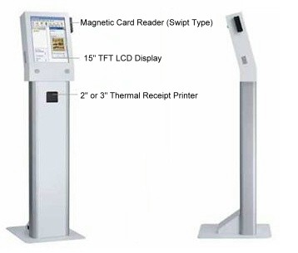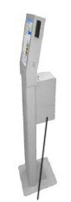
3” Thermal Printer with
Independent Power Supply
Features:
* Slim and Stylish Design
* Durable and Light Weight Construction
* MSR, Receipt Printer and Heavy Paper Loader Option for Augmented Versatility
* Customizable Solution

System Specifications
CPU | Intel Celeron 2.0 GHz
Chipset | Intel 852GM + ICH4
Memory | 512 MB DDR x 1 (optional up to 1 GB
Display | 15” TFT LCD, 1024 x 768, 250 nits
L2 Cache | CPU Built-in
Inside Cabinet I/O | Serial ports: 3 (COM1, 2 & 4 with +5V/12V, power output on pin 9, COM3 is Internal type reserved
 | Parallel port x 1 SPP/EPP/ECP
 | PS/2 Keyboard port
 | PS/2 Mouse port
 | USB Interface x 2
 | VGA Interface x 1 (Support second display)
Audio | Speaker x 2
Ethernet | 10/100 Base-T Ethernet with RJ-45
IDE | U DMA33/66/100, 3.5” 80 GB HDD
Optional Device | 2” Thermal Receipt Printer x 1  3” Heavy Loading Thermal Printer x 1  (With Independent Power Supply)  Magnetic Card Reader x 1
Power Supply | 120W, 100 – 240V/1.2A @50 ~ 60Hz
Dimension | 1450mm x 400mm x 476mm (H x W x D) with Stand
Touch | Resistive Type 5 Wires
Temperature | Operating: 0~ 50°C, Storage: -10°C~60°C
Humidity | 30~90% Non Condensing

HONOR STAR IND. CO., LTD.
P. O. BOX 78-17 Taipei (110), Taiwan, R. O. C.
Tel: 886-2-27636779(Rep.), Fax: 886-2-27644954
E-Mail: honorcom@ms35.hinet.net
Website: http://www.honorstar.com.tw

