20 Key POS Keyboard With Magnetic Card Reader
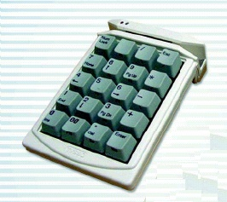

Specifications:

Interface | K/B, RS232 or USB
Power | Voltage: 5 volts ± 5%
Power Consumption | 40 mA
Capacity | 1 KB For Keys Program
Contact Resistance | 1 Ohm Max.
Insulation Resistance | 500M Ohm min.
Contact Bounce | 5ms Max.
Key Switch | Reliable & Pleasant Mechanical Key Switch
Key Number | Ergonomic & Elegant Design with 20 Keys Layout
Dimension | 135 x 97 x 40 mm (L x W x H)
Weight | 240 g
Magnetic Card Reader | Track(s): Comply ISO standard 1,2,3 combination

