Industrial Keyboard

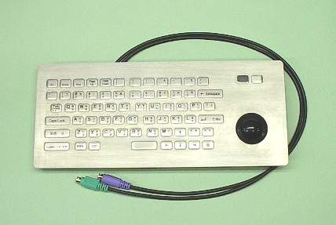
* Applications: The Industrial Keyboard can apply to Kiosk or Web Payphone
at Indoor or Outdoor environments.
* Specification:
a). Number of Keys: 65 (other keys available on request)
b). Key Travel: 0.6 mm ± 0.15 mm
c). Keyswitch Life Time:1 Million Operations
d). Electronic Interface: PS/2
e). Frontplate Material: Stainless Steel
f). Dimensions: 350 mm (L) * 150 mm (W)
g). Membrane Switch : Waterproof and Contaminant Proof.
h). There is a blind point on Key “F” and “J”. Keyboard,
i). Trackball and Human Senor can be All-in-one, Keyboard and Trackball
Module or single Keyboard to fit customer’s case-design. It’s easy installation.
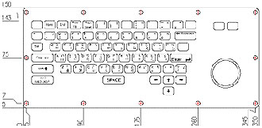

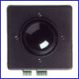
* Specification of Trackball:
a). Surface of Trackball is anti fire, robust & durable.
b). Ball diameter: 38.1mm
Weight: 133grams
c). Electronic Interface: PS/2
d). Operating Temperature: -25℃ to 70C Degrees
e). Encased stainless steel bearing

