In-Counter Laser Barcode Scanner
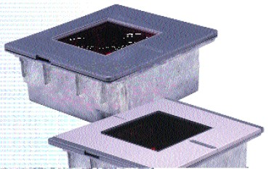
R
E
Scan Speed | 2000 scan lines per second | 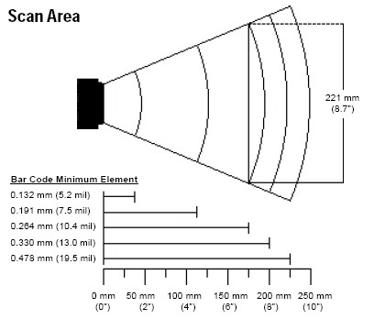
Scan Pattern | 5 fields of 4 parallel lines (omnidirectional)
Number of Scan Lines | 20
Minimum Bar Width | 0.127mm (5.0 mil)
Light Source | Visible Laser Diode 650 nm + 10 nm
Laser Power | 1.1 mW (peak)
Depth of Scan Field | 0 mm - 203 mm (0” - 8”) for 0.33 mm (13 mil) bar code
Width of Scan Field | 137 mm (5.4”) @40mm (1.6”); 221 mm (8.7”) @178 mm (7”)
Decode Capability | Autodiscriminates all standard bar codes | 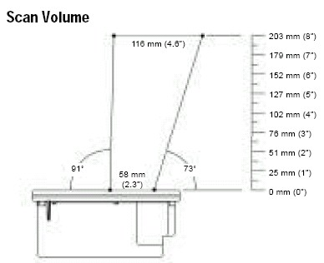
Interface | RS232, Light Pen Emulation, Keyboard Wedge, Stand Alone Keyboard, USB, OCIA
Print Contrast | 35% minimum reflectance difference
Number Characters | Up to 80 data characters
Roll, Pitch, Yaw | 360°, 60°, 60°
Beeper Operation | 7 tones or no beep
Indicators (LED) | Amber = laser on, ready to scan  Red = good read, decoding | 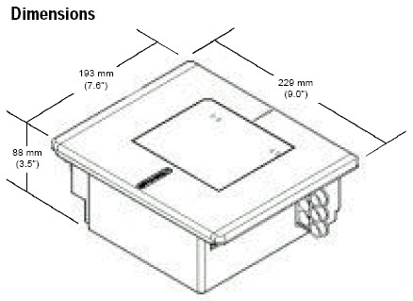
Dimensions | Length: 193 mm (7.6”)  Width: 229 mm (9.0”)  Height: 88 mm (3.5”)
Weight | 2.88 kg (6.35 lbs)
Termination | Three 10 pin modular RJ45
Cable | Standard 2.1 m (7’) straight
Input Voltage | 5.2 VDC + 0.25 V
Power | 2.6 W
Operating Current | 500 mA
DC Transformers | Class II; 5.2 VDC @ 650 mA
Laser Class | IEC 60825-1:1993 +A1:1997 +A2:2001 Class 1
EMC | FCC, ICES-003 & EN55022 Class A
Temperature Operating: | 0°C to 40°C (32°F to 104°F)
Storage: | -40°C to 60°C (-40°F to 140°F)
Humidity Operating: | 5% to 95% relative humidity, non-condensing
Light Levels | Up to 4842 Lux (450 footcandles)
Contaminants | Sealed to resist airborne particulate contaminants
Ventilation | None required

