Fixed Barcode Laser Scanner
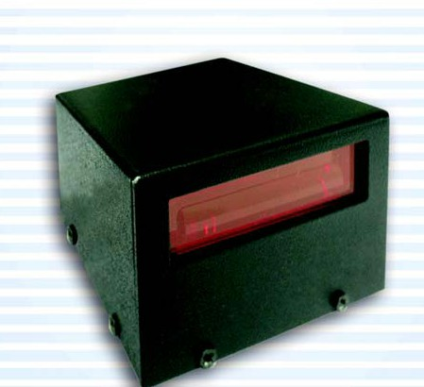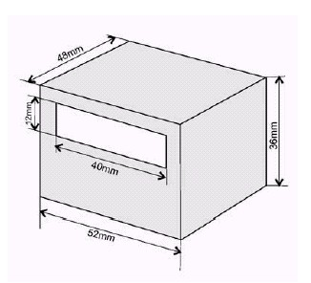
Features:

* High Performance, Small size for Fixed-Mount or Embedded Scanning Applications.
* Reliable High Quality Scanning, Software-controlled Trigger or Photo-switch Triggerless Operation for RS-232 interface.
* The Flag 900 combines compact, durable construction with barcode laser scanning technology for a rugged, reliable fixed-mount scanner that can also be used as an embedded module. Available in standard or long-range working distances for optional flexibility.
* The Flag 900 is designed with superior laser performance and sophisticated decoding algorithms, assure the highest first-time read rate and accuracy.
* Used as fixed-mount, non-contact scanners, the FLAG-900 is ideal for conveyer, library and document tracking applications.
* The Flag 900 is also ideal for embedded applications, such as banking ATM system, automatic test and processing equipment, and many other automated data entry devices.
R
E N V I R O N M E N T
Scan Speed | 50 or 33 scans per second
Wave Length | 670 nm + 10 nm
Max. Pitch | ±65 Degrees
Max. Skew | ±50 Degrees
Max. Depth For 40 mil | 18 cm
Max. Resolution | 4 mil (0.1mm)
Power Source | + 5VDC
Processor | Intel 80C31
Decoder | Proprietary
Body Material | Metal
Current Consumption | 55mA~90mA
Interface | RS232, Keyboard Wedge
Weight | 140g (Without Cable)
Shock Resistance | 1 Meter Drop Onto Concrete
Audible Indicator | Beeper Driver Output
Mounting | Screw Mounting To Case Bottom
Dimension | 52mm x 48mm x 36mm
EMI | FCC Class A
Temperature Operating: | 0°C to 50°C
Storage: | -20°C to 65°C
Relative Humidity | 5% to 95% non-condensing
Ambient Light | 3,000 to 8,000 Lux
Connectivity | DB9, DB25, AMP, RJ-45, RJ-11, DIN 5

