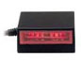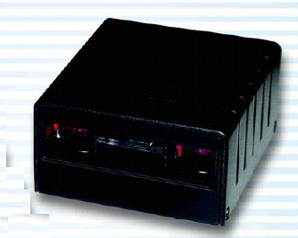
Reading Width | Up to 120 mm
PCS | Up to 0.45
Code Read | UPC/EAN/JAN, Code 39, Interleave 2 of 5, Industrial 2 of 5,  Standard 2 of 5, Matrix 2 of 5, Code 11, Code 128, Codabar, Code 93, MSI/PLESSEY, Code 4 and etc
Light Source | Red Led 660 nm
Sensor | 2048 pixels Linear CCD
Scan Speed | 100 Scans per Second
Depth of Field | 4” (100mm) for 20 mil (0.50mm) Barcode
Ambient Light | 4000 Lux max. (Fluorescent)
Resolution | 4mil (0.1mm)
Power Source | DC +5V, ±5%
Current Consumption | Stand by, 40mA; Active, 140mA
Operating Temperature | 0℃ to 45℃
Storage Temperature | -20℃ to 60℃
Relative Humidity | 20% to 85% (Non-condensing)
Material | PC + Fiber
Shock Resistance | 1 meter drop onto concrete
Connectivity | DB9, DB25, AMP, DIN5, Mini-Din 6, and etc
Dimension/ Weight | 60 mm(W) x 56 mm(L) x 29.5(H) mm/ 33g (except cable)
Interface | Keyboard, RS232

