Multifunctional Handheld Wireless Laser Scanner & Data Collector (Build in Laser, RFID Reader and Blue Tooth)

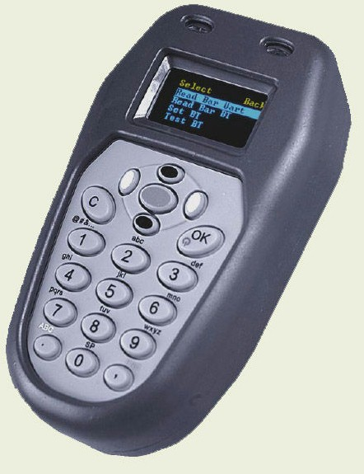
HDC-7630S HDC-7630D Cradle

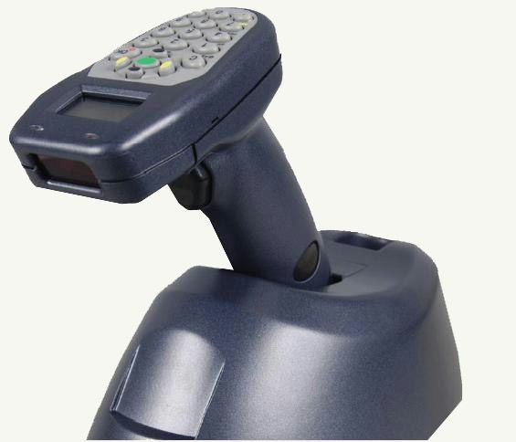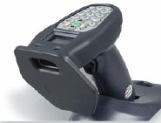
Laser & BT, Class I, 100m Long Range RFID design <= 20 cm
Features:
* Handheld bar code laser scanner & Data Collector.
* Laser reader (1D) or CMOS (1D/2D)
* OLED display, 128 x 64 resolution, two colors.
* Main body interfaces could be RS232/USB/Blue Tooth.
* Build in Blue Tooth, Class I, transmission distance <= 100 m.
* Build in RFID reader/writer, Mifare, I-Code, EPC….
* Rechargeable Li-ion battery 1200mA in main body or 2200mA in gun grid,
scanning time >= 10,000.
* 19 keys keypad for Alphanumeric input.
* Base Station for hand free scanning, data transmission and battery charging.

Specifications
CPU |  | ARM7, 32 bit RISC, 60MHz
Memory |  | RAM: 16kB  512kB Flash ROM  Extended Memory: 1MB Flash ROM
Display |  | OLED 128 x 64, two colors (Yellow/Green)
Keypad |  | 19 keys or 7 keys
Communication |  | RS232, 9600~115200 bps  Ethernet (option)  Blue Tooth Class I/II (option)  RFID 13.56MHz (option)
Battery |  | Li-ion 1200mAH or 2200mAH
Power Adapter |  | DC6V, 1.5A, AC 100~240V, 50~60Hz
Dimension |  | 105mm (L) x 57mm (W) x 24 mm (H)
Weight |  | 80 g (no battery)
Power Consumption |  | Idle: 8mA, Operation: 100mA (includes Laser)
Scan Module |  | Laser
Full Charge Scanning |  | > 10,000 times
Input Modes |  | Keypad, Laser, RFID (option)
Bar Code Symbologies |  | UPC, EAN, Code 39, Code 128, Interleaved 2 of 5
RFID readers |  | Mifare, I-Code
Operating Temperature |  | -0℃ to 40℃
Relative Humidity |  | 5% to 95% (Non-condensing)
Drop |  | 1.2m
Rain and Dust Resistance |  | IP54
Dimension/ Weight |  | 60 mm(W) x 56 mm(L) x 29.5(H) mm/ 33g (except cable)
Accessories |  | Rubber housing, Waist clip, Li-ion battery, Communication cable, Cradle
Handheld | RFID reader |  | RFID & Laser | Waist Clip
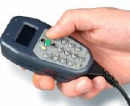 | 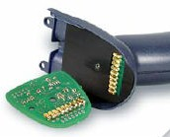 |  | 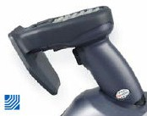 | 