External WiFi Media Network Box (D8)
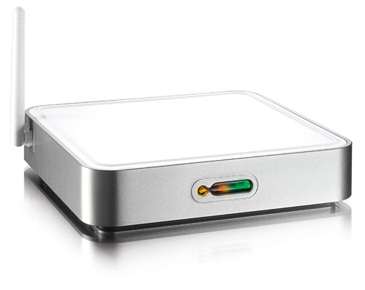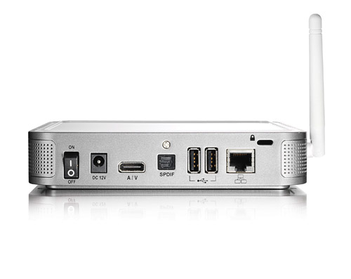
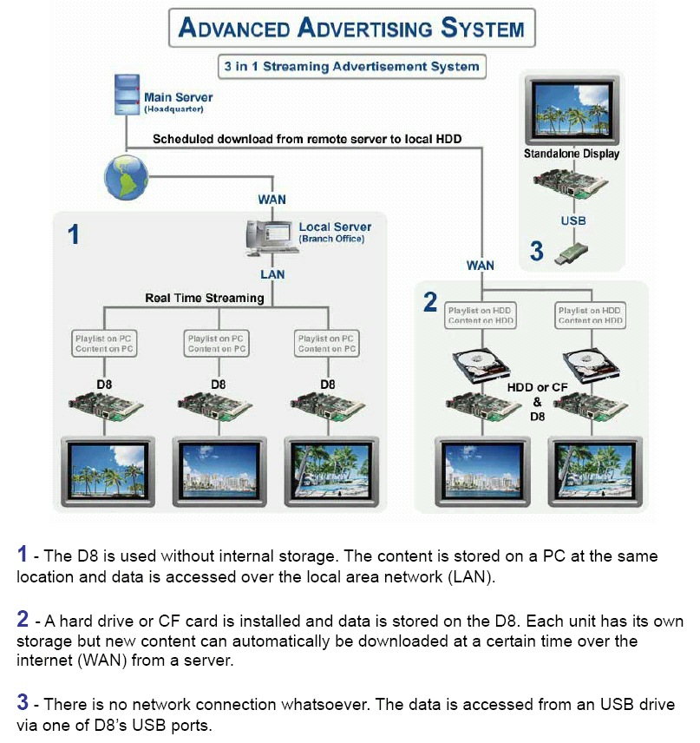
* Networking Advertisements on demand.
* Integrated HDD or CF (optional).
* High resolution output (1080i).
* Automatic synchronization with server time.
* Scheduled download content from Internet.
* Scheduled playback content at Local or Internet.
* USB Host 2.0 storage class support.
Hardware Specifications
Video Output | Composite Video, S-Video, VGA Component Video, SCART
Video Format, | PAL 576i/576p, NTSC 480i/480p, HDTV 720p/1080i  (MPEG 1/2/4, MP3, WMV9, ISO)
Audio Output | Stereo, SPDIF Digital Audio Output on Optical.
WLAN | Mini PCI Card Slot for IEEE 802.11/b/g
Networking | Ethernet 10/100-BaseT, Supports Samba Client, DHCPC, NTP, FTP Client, Http file get.
Remote Control | 47 Keys

