Hand Held CCD Barcode Scanner

Model | Type A | Type B
 | 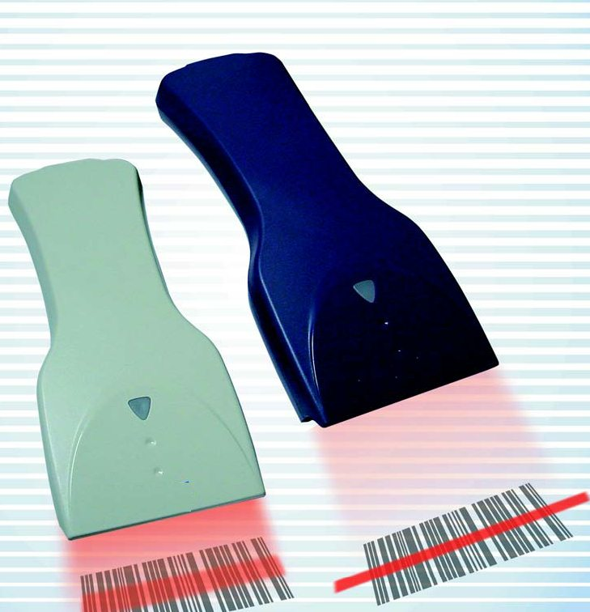 | 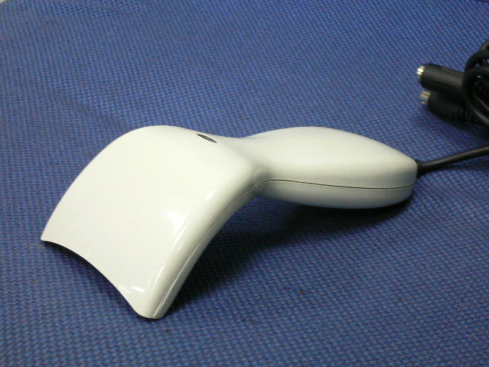
Reading Width | Up to 11 cm | 8.2 cm
Reading Depth | 2 cm up to 18 cm | 0~15 mm
Code Read | UPC/EAN/JAN, Code 39, Code 39 Full ASCII, Interleave 2/5, Code 11, Code 128, Codabar/NW7, Code 93, MSI/PLESSEY, Code 4 & etc
Light Source | Red Led 660 nm
Scan Speed | 33 to 100 Scans per Second
Resolution | 0.1 mm (4 Mil) Max.
Ambient Light | 3000 to 8000 Lux | 1500 Lux
Processor | Intel 80C31
Power Source | DC +5V, ±5%
Current Consumption | 140mA | 120mA
Operating Temperature | 0℃ to 50℃
Storage Temperature | -10℃ to 65℃
Relative Humidity | 5% to 95% (Non-condensing)
Body Material/ Shock Resistance | ABS/ 1 meter drop onto concrete
Connection Cable | 2 Meter, Straight
Connectivity | DB9, DB25, AMP, DIN5, Mini-Din 6, and etc
Dimension | 159 x 59.8 x 18.5 mm | 155 x 70 x 53 mm
Weight | 160g (except cable) | 130g (except cable)
Interface | TTL, Keyboard, RS232 & Wand Emulation, USB
EMI emission | FCC class A, CE

