Blue Tooth CCD Scanner

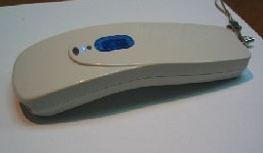

Features:

1.Online Bluetooth/RF 2.40-2.48Ghz wireless communication.
2.No user limits for multi-user application (up to 7 users for BT).
3.Built-in long range and high speed CCD scanning engine.
4.Working range up to 10 or 100meters.
5.Low power consumption with use of two AA batteries.
6.Slim and lightweight, elegant design.
7.Easy-carrying strap included.

