Barcode Slot Reader
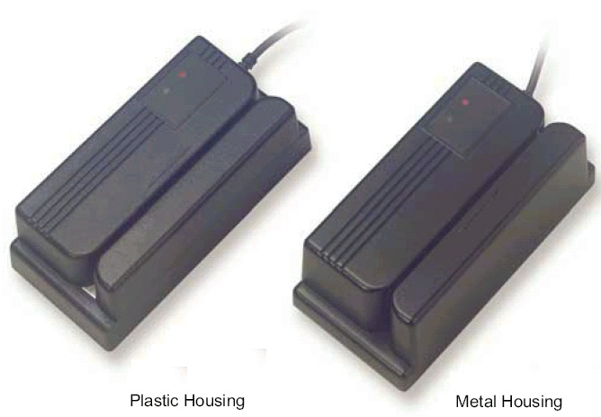
* Metal or Plastic Housing
* Scan Height can be Requested and Adjusted.
* TTL Module with Light Source can be upon OEM Request.
* High Performance, Read from 5 mil Resolution

Features:
* High Resolution
Compatible with virtually all barcode resolutions,
and compatible with most decoding software.
* Sealed ABS or Metal Case can be Requested
-Water splash proof design
-Can be installed out-doors or in wet environment.
* Tamper Proof Design
Ideal for security applications
* Available in either visible 660 nm or infrared 940nm versions.
* Operating Temperature Range: 0 C~55 C
* Available in Various Interfaces: TTL, Keyboard Wedge, RS-232 and USB

Scan Velocity | 70 ~ 500 mm/sec, Bi-direction
Code Read | UPC/EAN/JAN & Add on 2/5, Code 39, Code 39 Full ASCII, Interleave 25, Matrix 25, Standard 2 or 5  Code 128, Codabar, Code 93, MSI, Code 11, Code 4
Light Source | 660 nm Red LED Light /940 nm Infrared
Resolution | 0.127 mm (5 mil) at PCS 0.9
Ambient Light | 1000 LUX (Fluorescent Light)
Voltage | DC +5V
Power Consumption | 10 mA (Uudecoded Output), 50 mA (Decoded Output)
Interface | TTL, RS-232, Keyboard Wedge
Connector | DB9 Female, DB25 Male, AMP, DIN6, DIN5, PS/2, RJ-45, RJ-11, and etc.
Reading Indicator | Beeper & LED
Operating Temperature | 0℃ to 55℃/-20℃ to 70℃ (Storage Temperature)
Relative Humidity | 0% to 95% (Non-condensing)
Dimension | 123.5 mm x 123.5 mm x 33.0 mm(Plastic Housing)  123.5 mm x 60.5 mm x 36.5 mm(Metal Housing)

