32” Splash Proof LCD TV Monitor
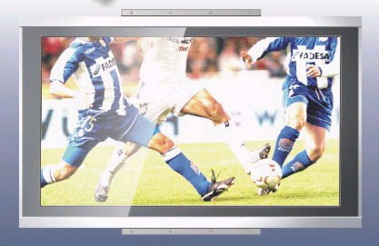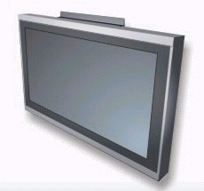

Screen Diagonal | 32” TFT LCD Panel, (16:9)
Pixel Pitch | 0.5175 x 0.5175 mm
Active Area | 697.68 x 392.26 mm (H x V)
Color Depth | 16.7 Million
Contrast Ratio | 800 : 1(Typ)
Brightness | 500 cd/m²(Typ)
Viewing Angle | 88/88 (H)/ 88/88 (V)
Signal Input | RGB Analog
Resolution | 1920 x 1080
Response Time | 12ms/12ms (Tr/Tf)
Lamp Life (Hours) | 60,000
Speaker | 10W X 2
PC – in | 15-pin D-SUB
I/O Connections | Tuner x 1  Component Input x 2 (480i, 480P, 576i, 576p, 720P, 1080i)  VGA 15 pin  S-Video  Video–in  PC Audio Input  Video Output (RCA x 1)  RS 232 Input
Power Consumption | 170W
Power Adapter | AC 100-240V, 50/60Hz
Key Features | Analog NTSC  Picture in Picture  CC/V-chip  Remote Control under 10M  3:2 Pull Down Compensation  View Mode (4:3/16:9)  PC Compatible  Timbre Function: MTS  OSD Control 8 Languages  3D Comb Filter  Auto Channel Scan  Sleep Timing
Dimension | 821 (W) x 515(H) x 79(D) mm
Weight | 23 Kg
Certification | IPX6

