2D Barcode Scanner
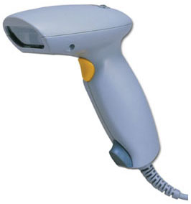
This 2D(two dimension) hand-held input device incorporates the latest digital image capture and processing technology for the next generation. It is capable of auto-discrimination reading and decoding one dimension and two dimension bar code symbologies. Its lightweight, compact and ergonomic design allows the reader to be used in repetitive , high volume hand scanning operations in even the most demanding environments.

SPECIFICATIONS
Physical | Length  Width  Depth  Weight | 146.9mm  76mm  131.8 mm  160g Ambient
Bar Code | 2D  1D | PDF417, DataMatrix, QR Code  UPC/EAN/JAN, Code 39,Code 128, Codabar, ITF 2/5
Optical | Pitch  Skew  Rotation  Ambient Light | 45 °  45 °  360 °  0 to 100,000Lux
Read Distance Area | 76mm  127mm  203mm  305mm | 40 x 30mm  67 x 50mm  107 x 80mm  160 x 120mm
Depth of  Field | 1D Barcode  0.25mm  0.33mm  PDF 417  0.17mm  0.25mm  DataMarix QR Code  0.25mm  0.38mm  OR Code  0.25mm  0.33mm | Near Far  90mm 180mm  90mm 230mm  25mm 125mm  50mm 180mm  90mm 125mm  90mm 150mm  45mm 115mm  35mm 155mm
Interface | Serial  Format  Baud Rate  Power Requirement  Average Power Consumption  Peak Power Consumption | RS232C  ASCII or Bit Map (Image)  9600 to 115.2 kbps  5V  250mA@5V  500mA@5V
Environment | Operation Temperature  Humidity  Shock Resistance | 0° to 60 ° Centigrade  0 to 80% RH  1.5 M to Concrete Floor

