20” High Performance Panel PC
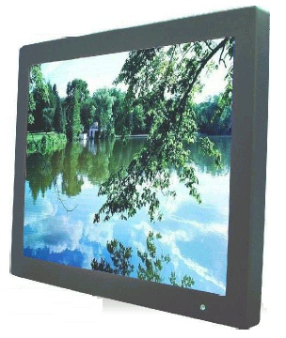
System Specifications
CPU Socket | Socket 479 or CPU on board
CPU | Intel Pentium M/Celeron M Up To 2.0 GHz
Front Side Bus | 400 MHz
Chipset | Intel 855GME/ICH4
Memory | One 184 Pin DDR DIMM Max. 1GB
BIOS | Award 4 Mbit
VGA Controller | Intel 855GME Integrated, Shared Memory Max. 64 MB
LCD Support | 24 bit LVDS (Dual Channel)
Ethernet | Intel ICH4 Integrated + PHY 82565EZ  Intel 82541 GI Gigabit Ethernet (option)
Audio | Built in Audio AC97 Codec
IDE | 1 U DMA33/66/100, 2.5” 80G HDD
Super I/O Chipset | W83627HF
Parallel | 1 SPP/EPP/ECP Port
Serial | 2 x RS232
Fire Wire | 2 x 1394
USB | 2 External Port / 2 on Board Pin Headers
IrDA | Yes
KB/Mouse Connector | PS/2
Watch Dog Timer | 256 Levels
Expansion Slots | Mini PCI, Internal/Socket
Power Adapter | DC In 12V
IP65 | Optional
Form Factor | Mini ITX
DVD (optional) | Standard Slim DVD ROM/Combo/DUAL
FDD (optional) | 3.5” 1.44MB FDD + 7 in 1 Card Reader
Mechanical | Chassis, Black Color
OS (Optional) | Windows XP Embedded
Temperature | Operating: 0~ 50°C, Storage: -10°C~60°C
Humidity | 5~95% Non Condensing
Cooling | Fan Cooling Concept
Shock | Operating: 15G, 11ms Duration
Vibration | Operating: 5 Hz~500 Hz/ 1 Grms/3 Axis  Packing: 5 Hz~500 Hz/ 2.16 Grms/3 Axis
Safety | FCC-A, CE-A

LCD Specifications
LCD Display | 20” TFT Panel
Pixel Pitch | 0.255 x 0.255 mm
Contrast ratio | 700:1
Display color | 16.7 colors
Brightness | 250 cd/m²
Viewing Angle (CR≧10) | -85~85(H), -85~85(V)(Typ.)
Active Display area | 408.0mm(H)×306.0mm(V)
Scanning Frequency | H: 31.5-80 KHz; V: 56-75Hz
Recommended Resolution | 1600 x 1200
Power source | AC 100-240V Universal
Power Consumption | 32W typical, normal operation
Power Management | VESA DPMS Compliant
Touch Screen (Optional) | Resistive, USB or RS232 Interface
Plug & play | VESA DDC 1/2B

