20.1” Open Frame/Metal Housing TFT LCD Monitor (1366 x 768, 16:9)

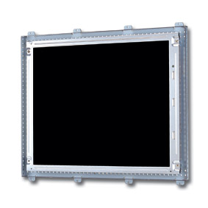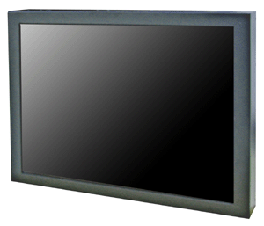
Screen Diagonal | 20” 16:9 Active Matrix TFT
Resolution | 1366 x 768
Pixel Pitch | 0.3255(H) x 0.3255(V)mm
Color Depth | 16.7 M
Contrast Ratio | 800 : 1(Typ)
Brightness | 500 cd/m²(Typ)
Response Time | 9 ms
Viewing Angle | 176° (H), 176° (V)
Signal Input | RGB Analog
PC In | 15 Pin D-SUB
OSD Control Key | Power, Menu/Enter, Left, Right, Source, Up/Channel Up, Down/Exit
OSD Language | English/Chinese
Power Consumption | 55 Watt
Dimension/Weight | 590(W) x 470(H) x 210(D) mm /8.7 Kg
Packing | 682(W) x 525(H) x 275(D) mm /13.02 Kg
Safety | FCC, UL, CE, TUV & BSMI

