15” Desktop Panel PC
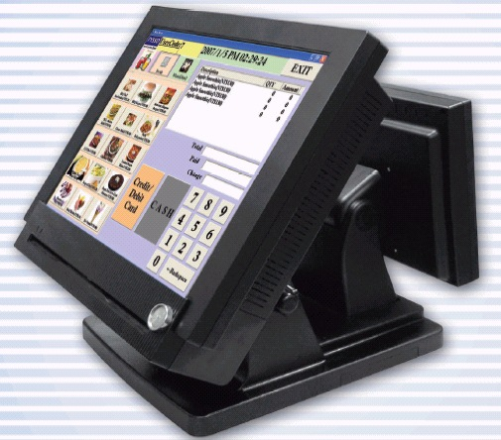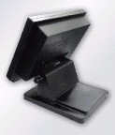

SPECIFICATIONS
Processor | Intel Celeron M Dothan 1.2 + GHz (upgradeable to Pentium M) | AMD Geode 500 MHz embedded
System Memory | Standard 256MB, 1 x 240 pin DDR2 (expandable to 1GB) | Standard 256MB, 1 x 400 pin SODIMM DDR400 (expandable to 1GB)
Graphic Memory | Default 8 MB, expandable to 64 MB shared memory from system memory
Flash Memory | Compact Flash (Type I & II)
IDE Hard Disk | 1 x 2.5” Drive 40 G
LCD Size | 15" TFT LCD, 1024*768, 250~350 nits
Touch Screen | 5 wire Resistive type
Tilt Angle | 0 ~ 80°
PS/2 Keyboard | 1 |  | 1
PS/2 Mouse | 1 |  | 1
USB 2.0 | 4 |  | 3
COM | 4 ( pin 9 provide +5V/+12V by jumper
Parallel | 1 |  | 1
Cash Drawer | 2 x RJ11 (12V or 24V default) |  | N/A
LAN (10/100) | 1 (RJ45) |  | 1 (RJ45
Audio Port | Line out, MIC |  | Line in, Line out, MIC
CF Card Reader | N/A (Factory installed) |  | 1
Power Supply | External 150W Power Adapter |  | External 80W Power Adapter
Environment
EMC & Safety | FCC Class A, CE
Operating Tempe. | 0 ~ 45°C / -20°C ~ + 60°C (Storage)
Operating Humid. | 20% ~ 80% RH non condensing/20% ~ 80% RH non condensing (Storage)

Peripheral
Magnetic Card Reader (Triple tracks) | RS 232 interface
I-Button | RS 232 Interface (Optional)
Customer Display | VFD/LCD type (Optional)
Second Monitor | 10.4”/12.1”/15” TFT LCD (Optional)
40 key Keypad | RS 232 or PS/2 (Optional)
Mounting Type | Table Top or Wall Mount
Dimension | 367 x 356.5 x 335.94 mm (L x H x D)
Weight | N.W. 9 kg/ 10 kg (G.W.)
OS Support | Windows XP, WEPOS, XP Embedded, XP Professional for Embedded, Win 2000 Professional Embedded, Win NT 4.0, Linux.

